.

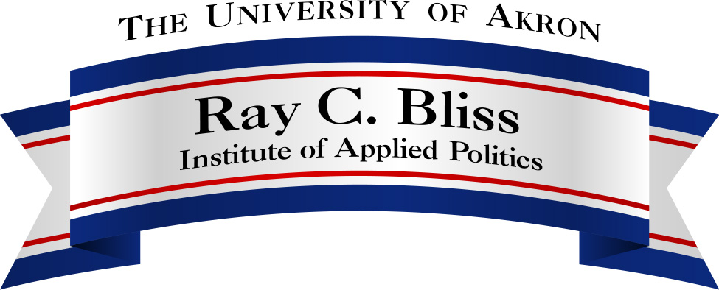

Message and Strategy:

Television Advertisements and the 2004 Presidential Election

February 11, 2005
Martin University Center
105 Fir Hill, Akron, Ohio

1:30 – 3:00 p.m.
2004 Presidential Election Campaign Strategies
Bush Campaign – Mark McKinnon, Political Strategies, Inc.
Kerry Campaign – Tad Devine, Shrum, Devine & Donilon

3:15 – 3:30 p.m.
Break

3:30 – 4:30 p.m.
Question and Answer Session

Ray C. Bliss Institute of Applied Politics The University of Akron
Akron, Ohio 44325-1914
Phone: 330-972-5182
Email: bliss@uakron.edu
Website: www.uakron.edu/bliss

