Creating Your Research Strategy

Research question ___________________________________________________________________________________

Type of project (i.e., 5 minute speech) _______10 item bibliography_

Types of information that may be useful: Books, articles, websites

Resources to search: UA Catalog, OhioLINK, Music Index, RILM, JSTOR, Google

_________________________________________________________________________________________________________

Search strategy (see below) __** DON’T WORRY ABOUT THE “*” NOW

_________________________________________________________________________________________________________

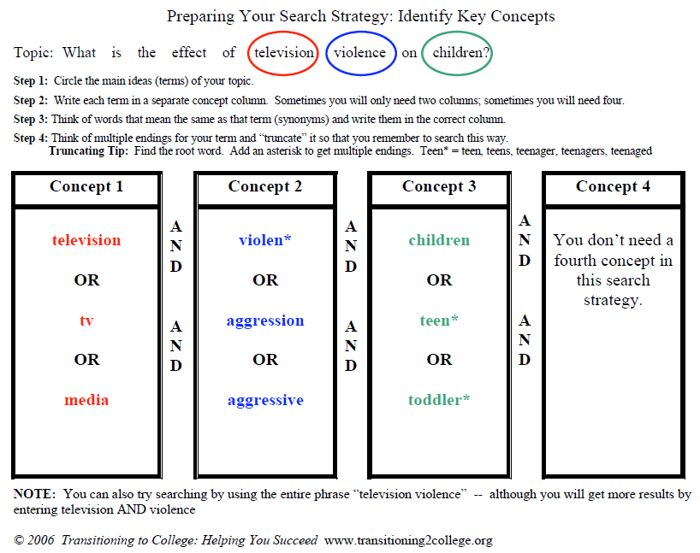

Also write several less specific (broader) and more specific (narrower) search terms for each keyword, in case there is too little or too much information on your given topice.

Example:

“Television”: Broader – “Media”, Narrower – “News” or “Cable Programs” or “Drama”

“Violence”: Broader – [not really a broader, maybe just take it out], Narrower – “murders”

“Children”: Broader – People [or just take out], Narrower – “pre-school” or “toddler”

