You are not too late! Undergraduate Field Orientations coming up for social work students interested in beginning their field education experience in Summer or Fall?

Upcoming scheduled field orientations for both groups | see below & additional details on website: click here

Akron Campus Students Only | Summer 2018
Part I | Friday, February 23, 2018 | 9 a.m. - 1:30 a.m. or 12:30 p.m. -3:00 p.m. Registration
Part II | Friday, April 6, 2018 | 9 a.m. -11:30 a.m. or 12:30 p.m. -3:00 p.m. Registration
Location | All Orientations | College of Arts & Sciences (CAS) | Computer Lab | Room 103A
Contact person| Naomi White | 330-972-5978

Akron Campus Students Only | Fall 2018
Part I | Friday, February 23, 2018 | 9 a.m. - 1:30 a.m. or 12:30 p.m. -3:00 p.m. Registration
Part II | Friday, April 6, 2018 | 9 a.m. -11:30 a.m. or 12:30 p.m. -3:00 p.m. Registration
Location | All Orientations | College of Arts & Sciences (CAS) | Computer Lab | Room 103A
Contact person| Naomi White | 330-972-5978

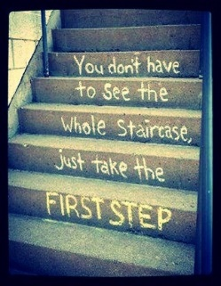
Contact your Academic Advisor & schedule a meeting to confirm your eligibility to enter field
- 2.75 grade point average in social work courses|
- 2.75 overall grade point|
- Senior status with 90 credits completed (of 120 credits hour
required for graduation)|
- Completed Practice I, Skills Lab | and
- Completed Practice II & earned a passing grade before starting
field education experience

Depending upon when you are entering field- summer or fall
- Complete & submit electronic field orientation registration
- Select one of two times
- Note location of field orientation – College of Arts & Sciences

- Complete electronic Application for Field and submit to fieldsocialwork@uakron.edu
- Confirm with your Academic Advisor to electronically submit your Undergraduate Student Academic Field Eligibility Form
- Take a look at the 200+ agencies available on our Agency Roster

- Breathe
- Feel free to get excited
- Come to Part 1 field orientation prepared for: Part
lecture, Part Practice, Short Assessment, and much
excitement
- Confirm registration for Part 2

More questions? contact Naomi White naomi1@uakron.edu | Polsky Bldg, Room 407 |330-972-5978 | Remember check-out our website

