How to Request Accommodations

Log into STARS and navigate to the Accommodation Requests section on the Dashboard. Select the plus sign or Add Requests to begin to select accommodations.

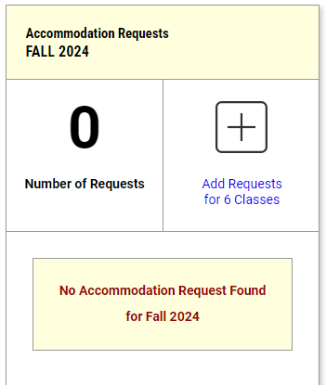

Select the checkbox beside each course where accommodation(s) are being requested. Then select Continue to Next Step.
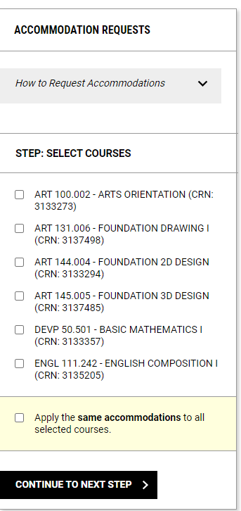

If any courses are non-lecture, confirm to proceed with requesting accommodations and select Continue to Next Step.

Select accommodations is only for accommodation(s) that requires pre-semester coordination. Please note that only accommodations for which are approved, eligible and need coordination, will show under Select Accommodations. For each course, select any clickable accommodations and then submit the accommodation request(s) by selecting Submit Request under Final Step.

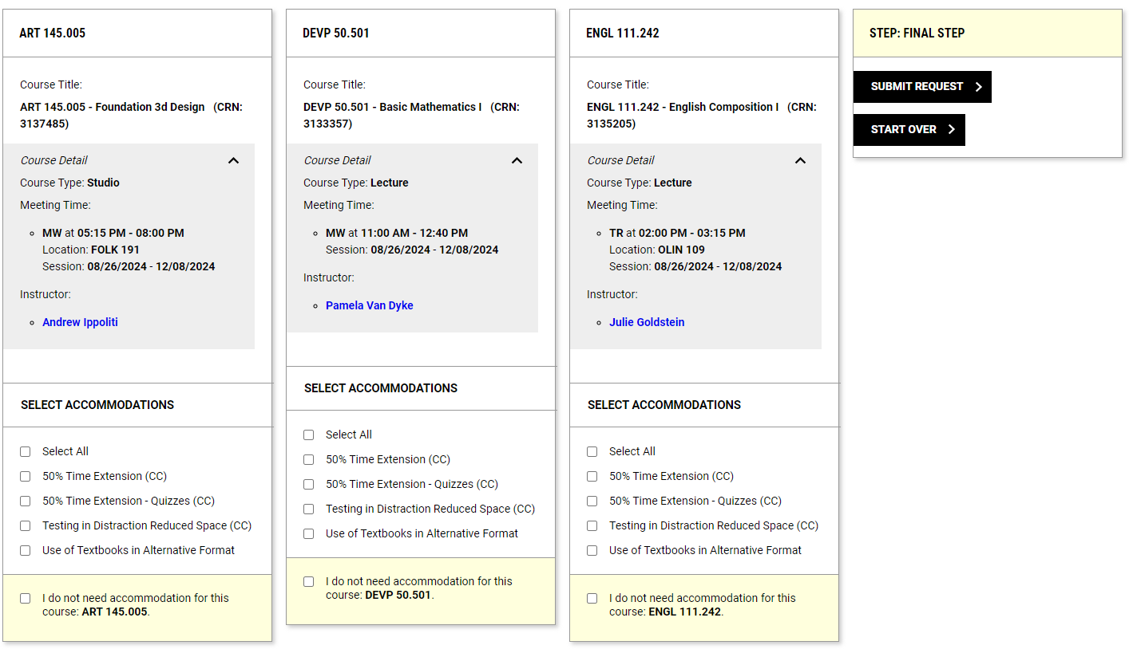

To modify a request, select the View Request detail under Accommodation Requests on the dashboard.

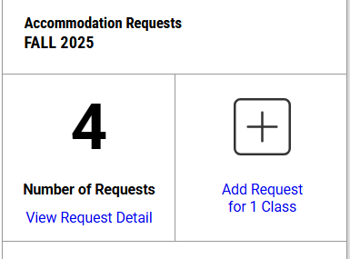

Find the class for which the request needs modified and select Modify Request.
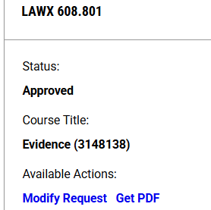

Make the changes to the request and select Update Request, to save the changes.

