Schedule, Cancel or Modify an Exam

- Open STARS and select the Alternative Testing tab, under Accommodations.

- Select the course under the Schedule an Exam header and select Schedule an Exam. Only classes for which your instructor has completed the Alternative Testing Agreement will appear. If the class you need to submit a test request for is not available to select, please contact your instructor to request they complete the Alternative Testing Agreement found on your letter of accommodation.

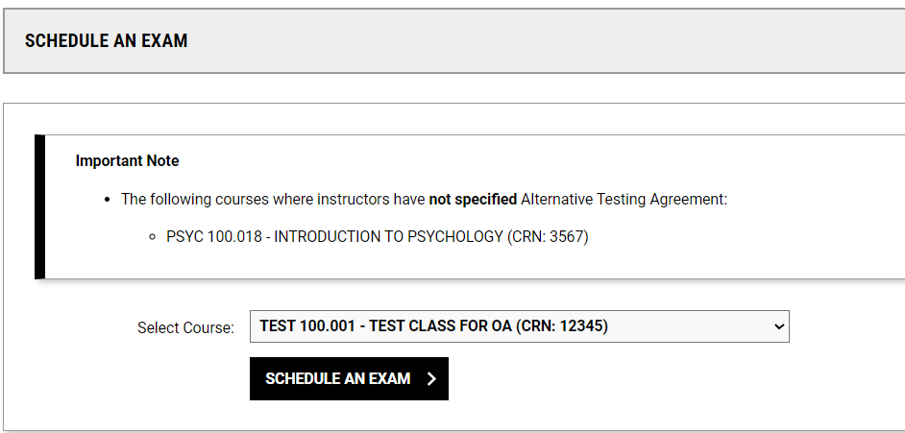

- Select the Exam Date, Time, Services Requested, and any Additional Notes that you may have regarding the exam. If the date is not specified, select The Exam I’m Scheduling is Not Listed and add the information to the request. Once completed, select Add Exam Request.

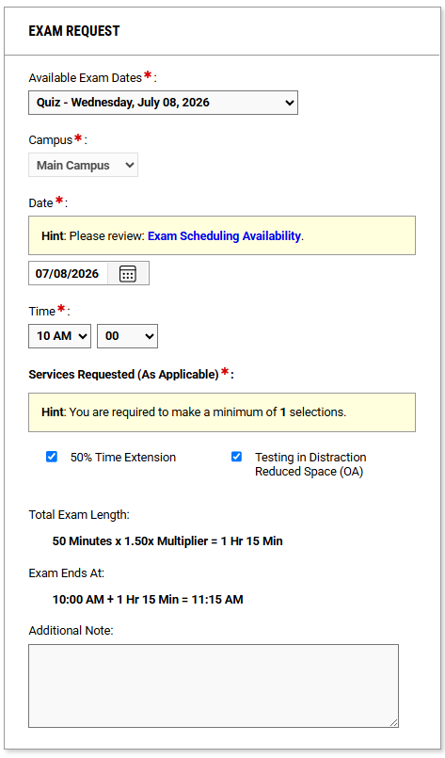

- To modify a request, select the Alternative Testing tab on the left-hand side. To modify the request, make changes to the exam request and select Update Exam Request.

- To cancel an exam request, select the drop down Cancel Exam Request. Indicate the cancellation request and select Cancel Exam Request.
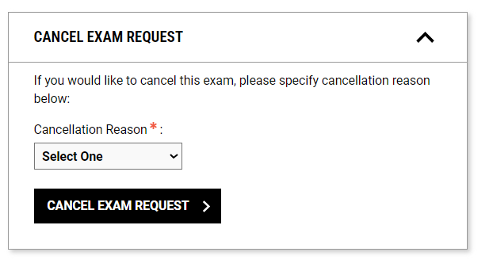

Late Exam Requests:
- If the exam request you are submitting is considered late, meaning you are submitting the request less than four business days in advance for tests and quizzes or less than one week in advance for midterms and finals, a Late Exam Request screen will appear after you click Add Exam Request. Your late exam request will not be submitted for review unless you complete the Late Exam Request box and submit the late exam request.

