Notetaker Registration

- Navigate to STARS and Select Sign Up as a Notetaker to sign in with your UANet ID and password. Enter your personal information, your email address needs to be UA email. If you are already a notetaker, select the Notetaker tab on the left-hand side.

- In the Find a Course section, enter the subject, course and section number for the courses in which you wish to be a notetaker.

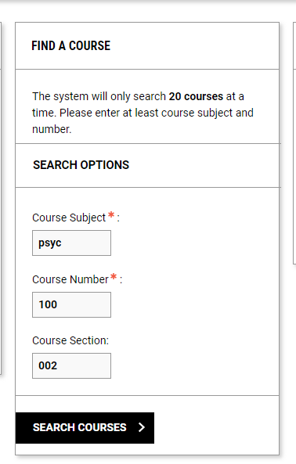

- The search result will appear to the right of the Find a Course section. Select the course by clicking on the highlighted link, in this case the 3574 – PSYC 100.002. When you select the link, the course will show up under the semester box on the left-hand side of the page, with the title of the semester and the search results will disappear.

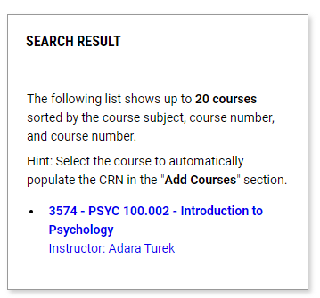
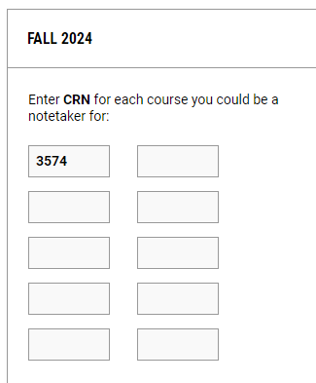

- If you have multiple courses, continue this process until all courses are added and select Add Courses.

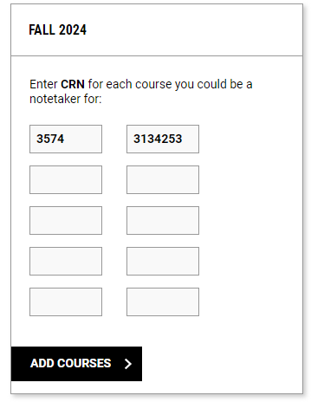

- Select the checkbox by each course on the next screen

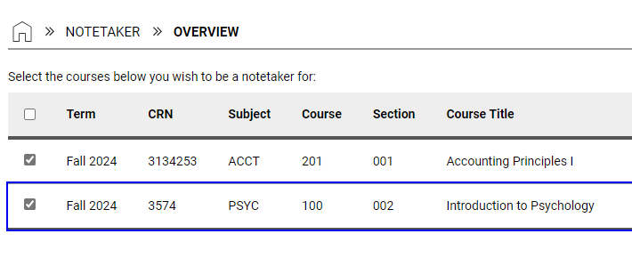

- Read and sign the notetaker contract exactly as it indicates and Submit your Request to be a Notetaker.

