Notetaker Signing Invoice

- Log into STARS and select the Notetaker module.

- Select the course and provide your address and signature, as listed exactly.
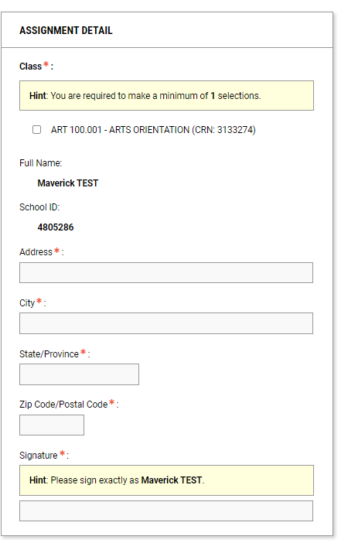

- Once completed, select Submit Assignment Verification so the student can review the invoice.
