Uploading Notes to STARS

- Log into STARS. On the left-hand side of the page select the Notetaker icon.


- In the Assignments menu, select Upload and View Notes.
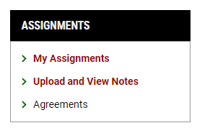

- Fill out the File Information by selecting the Class, Week under Notes for and Day(s). Browse your computer for the file to upload under Select File.

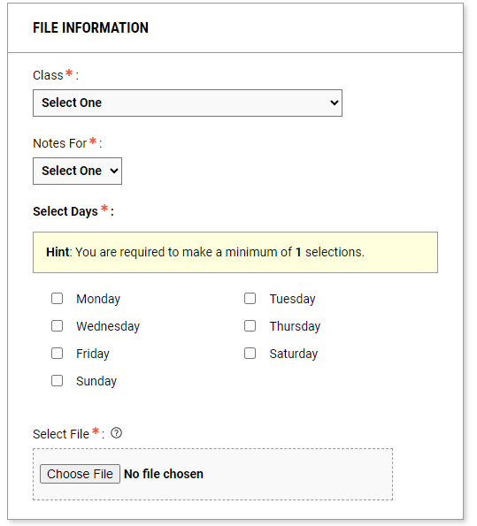

- Once the file is attached, select Upload File.
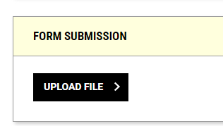

- Below the file information section are all the files that have been uploaded to the course. If the incorrect file has been uploaded, delete and upload the correct notes.

