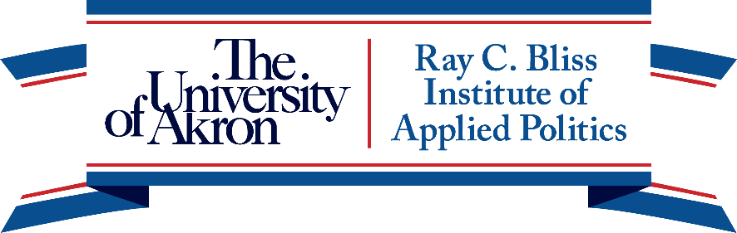

**STATE OF THE PARTIES: 2024 AND BEYOND**

**CONFERENCE SCHEDULE**

**THURSDAY, NOVEMBER 6, 2025**

**7:30 a.m. – CONFERENCE REGISTRATION**

Hilton Garden Inn, 1307 E. Market Street, Akron, OH 44305

**8:30 – 10:15 a.m. – STATE OF THE PARTIES**

Moderator: TBD

The Long and Winding Road to 2024: Critical Stops on the Road to the Parties of 2025

**Byron Shafer**, University of Oxford and University of Wisconsin, and **Regina Wagner**, University of Alabama

What Can We Learn from Ranney and Kendall about Trump’s GOP?

**Rick Farmer**, Southern Nazarene University, and **Christopher H. Owen**, Northeastern State University, Tahlequah

What do Party Elites Think about Election Reform?

**Robert Boatright**, Clark University, **Karen Sebold**, University of Arkansas, **Eric Heberlig**, University of North Carolina, Charlotte, **Caroline J. Tolbert**, University of Iowa

Gender, Intersectionality, and Democratic Party Culture

**Cecilia Ritacco**, Georgetown University

**10:15 a.m. - BREAK**

**10:45 a.m. – 12:15 p.m. - PARTY FACTIONS**

Moderator: TBD

Factions among Major Party Elites

**Geoff Layman**, Notre Dame University, **John Green**, University of Akron, and **Shay Hafner**, University of Notre Dame

Feeble Gatekeepers: Factional Insurgency and the Toppling of the Grand Old Party

**Zachary Albert**, Brandeis University, and **Raymond J. La Raja**, University of Massachusetts, Amherst

Insurgent and Consociational Factions and the Prospects for the Democratic Party

**Ronald B. Rapoport**, College of William and Mary, and **Andrew Engelhardt**, SUNY-Stony Brook

Factions and Parties in a Polarized Era

**Michael Ensley** and **Zach Morris**, Kent State University

**12:15 – 1:15 p.m. – Lunch**

**1:15 – 3:30 p.m. – STATE AND LOCAL PARTY POLITICS**

Moderator: TBD

Coalition Change or Pocketbook Election? Evidence from Nevada in 2024

**Kenneth M. Miller**, University of Nevada, Las Vegas

What Happened to the “Blue Wall”? The Partisan Makeup of Michigan, Pennsylvania, and Wisconsin, 1992-2024

**David A. Dulio**, Oakland University, and **Stephen K. Medvic**, Franklin & Marshall College

Did the Democratic Party Abandon Rural America? Evidence from a Survey of Local Party Officials

**Daniel M. Shea**, Colby College

Shifting Allegiances: Trump and Muslim Voters in the 2024 Election

**Daniel Hummel**, University of Louisiana at Monroe

The Organizational Structure of State Parties

**Doug Roscoe**, University of Massachusetts Dartmouth

State Democratic and Republican Political Party Chairs, 2015-2024

**Matthew J. Geras**, University of Illinois Springfield

**5:30 p.m. – Reception**

**6:30 p.m. – Dinner**

**8:00 p.m. – Keynote Speaker: Daniel M. Shea, Title TBD**

**STATE OF THE PARTIES: 2024 AND BEYOND**

**CONFERENCE SCHEDULE**

**FRIDAY, NOVEMBER 7, 2025**

**7:30 a.m. – CONFERENCE REGISTRATION**

Hilton Garden Inn, 1307 E. Market Street, Akron, OH 44305

**CONCURRENT PANELS – Please choose one of the following:**

**8:15 – 10:00 a.m. – PARTY RESOURCES**

Moderator: TBD

Political Party Contacting in the 2024 Election

**Brian J. Brox**,Tulane University

Carpetbag Campaigning: How Parties Reshape Democracy by Redirecting Resources to Competitive Districts

**Hans Noel**, Georgetown University

The Trump Donor 2015-2024: Are They That Different from Other GOP Contributors and What Impact Will They Have on Partisan Fundraising?

**Andrew Dowdle**, **Joshua Mitchell**, and **Karen Sebold**, University of Arkansas

The Impact of Organizational Characteristics on Super PAC Spending in Congressional Elections

**Paul Herrnson**, University of Connecticut, and **Jay Goodliffe**, Bringham Young University

**8:15 – 10:00 a.m. – PARTY CONSTITUENCIES**

Moderator: TBD

Diploma Divide, Rural Revolt, or Racial Realignment? Working-Class Partisanship in the Trump Era

**Michael E. Shepherd**, University of Michigan

The Polarized Type: Affective Polarization and Issue Polarization Among the Party-In-The-Electorate

**Jeremiah J. Castle**, Metropolitan State University of Denver, **J. Cherie Strachan**, University of Akron, and **Kyla K. Stepp**,Central Michigan University

Bridging the Age Gap: Young Voters and the Future of the Democratic Party

**Patrick McSweeney**, Georgetown University

House Party: Patterns of Inter-generational Party Transmission

**Daniel A. Smith**, **Olivia Zhang**, **Joselie Charles**, **Lara Adams**, **Samantha Cuenot**, and **Yugo Wang**, University of Florida

**10:00 – 10:30 a.m. – BREAK**

**CONCURRENT PANELS – Please choose one of the following:**

**10:30 – 12:00 p.m. – PARTY NOMINATIONS**

Moderator: TBD

Party Asymmetry in Competition in Presidential Nominations

**Caitlin E. Jewitt**, Virginia Tech, and **Gregory Shufeldt**, University of Indianapolis

A Rent-Seeking Theory of Political Parties

**Wayne Steger**, DePaul University

Differing Voter Criteria and Primary Polarization

**Barry C. Burden** and **Matthew Kim**, University of Wisconsin-Madison

Loyalty, Voice, and/or Exit Following a Loss: The Reactions of Overseas Democrats to the 2024 U.S. Elections

**James A. McCann**, Purdue University, and **Ronald B. Rapoport**, College of William & Mary

**10:30 – 12:00 p.m. – MAJOR PARTY ALTERNATIVES**

Moderator:

Third Parties and the Future of U.S. Democracy: Examining 2024 Within a Historical Framework

**Bernard Tamas**, Valdosta State University

Does Partisanship Matter? Adoption and Implementation of RCV in Red and Blue Jurisdictions

**Jay Wendland**, Daemen University

Partisan Polarization and Menstrual Equity Policies in U.S. State Legislatures

**Sara Chatfield**, University of Denver

Legislative Supermajorities and Direct Democracy: What is the Relationship Between Supermajority Legislatures and Citizen-Led Initiatives?

**Reynold F. Nesiba**, Augustana University

**12:00 – 2:00 p.m. – Lunch Speaker hosted by the Akron Press Club**