The University of Akron, Graduate School

Graduate Assistantship Handbook

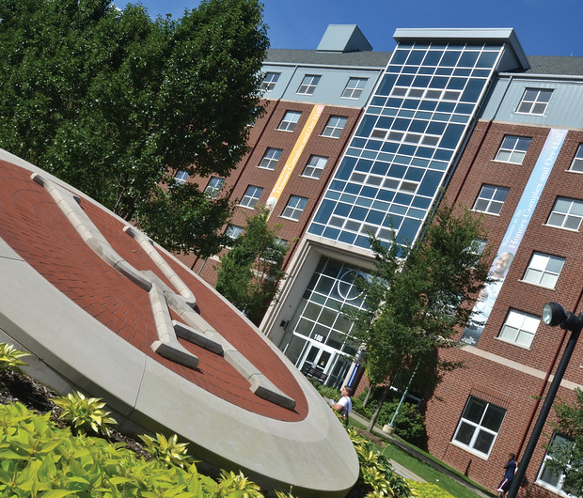

Graduate Assistantship Handbook

Table of Contents
FOREWORD
INTRODUCTION
THE GRADUATE ASSISTANT
Graduate Assistant as Graduate Student
Graduate Assistant Orientation
Graduate Assistant Supervision
TYPES OF AWARDS/APPOINTMENTS
Graduate Assistantships
Teaching/Laboratory Assistantships
Research Assistantships
Administrative Graduate Assistantships
Tuition Awards
TERMS, CONDITIONS AND BENEFITS OF ASSISTANTSHIPS
Offers and Acceptances
Eligibility
Academic Performance
Oral English Proficiency Assessment
Verification of Employment Eligibility and Identity (Form I-9)
Assistantship Funding Duration
Renewals of Appointments
Non-renewal
Termination/Resignation Before End of Appointment
Other Simultaneous Employment
Duties
Minimum and Maximum Credit Hour Enrollment Requirements
Stipends
Tax Status of Stipends
Payroll Procedures
Payroll Exemptions during the Summer Session
Remission
Holidays/Vacation
Leave of Absence
Health Insurance
Workers’ Compensation
Retirement
PROCESSING OF ASSISTANTSHIP AND TUITION SCHOLARSHIP AWARDS
RIGHTS AND RESPONSIBILITIES
DIVERSITY, EQUITY AND INCLUSION STATEMENT
ANTI-DISCRIMINATION & HARASSMENT POLICY
GRIEVANCE PROCEDURE
QUESTIONS
TEACHING RESOURCES AT UA
CAMPUS RESOURCES

FOREWORD

WELCOME to The University of Akron!

We are pleased that you have selected The University of Akron for your graduate preparation, and we are delighted that you have been selected to serve as a Graduate Assistant for this academic year. As a Graduate Assistant, you will be employed in academically relevant environments in teaching, research, or administrative service throughout the University community. The assistantship experience will enhance and complement your graduate studies here.

This handbook was designed to provide you with important and useful information about your assistantship. It will serve as a quick reference guide to the policies and procedures related to University assistantships and tuition scholarships.

The University of Akron is dedicated to the ideals of exemplary scholarship and high standards of achievement that characterize graduate education. It is the purpose of this handbook to provide information that pertains to the academic and administrative processes of providing this financial support. We extend to you the very best wishes from the staff of the Graduate School for your success this academic year.
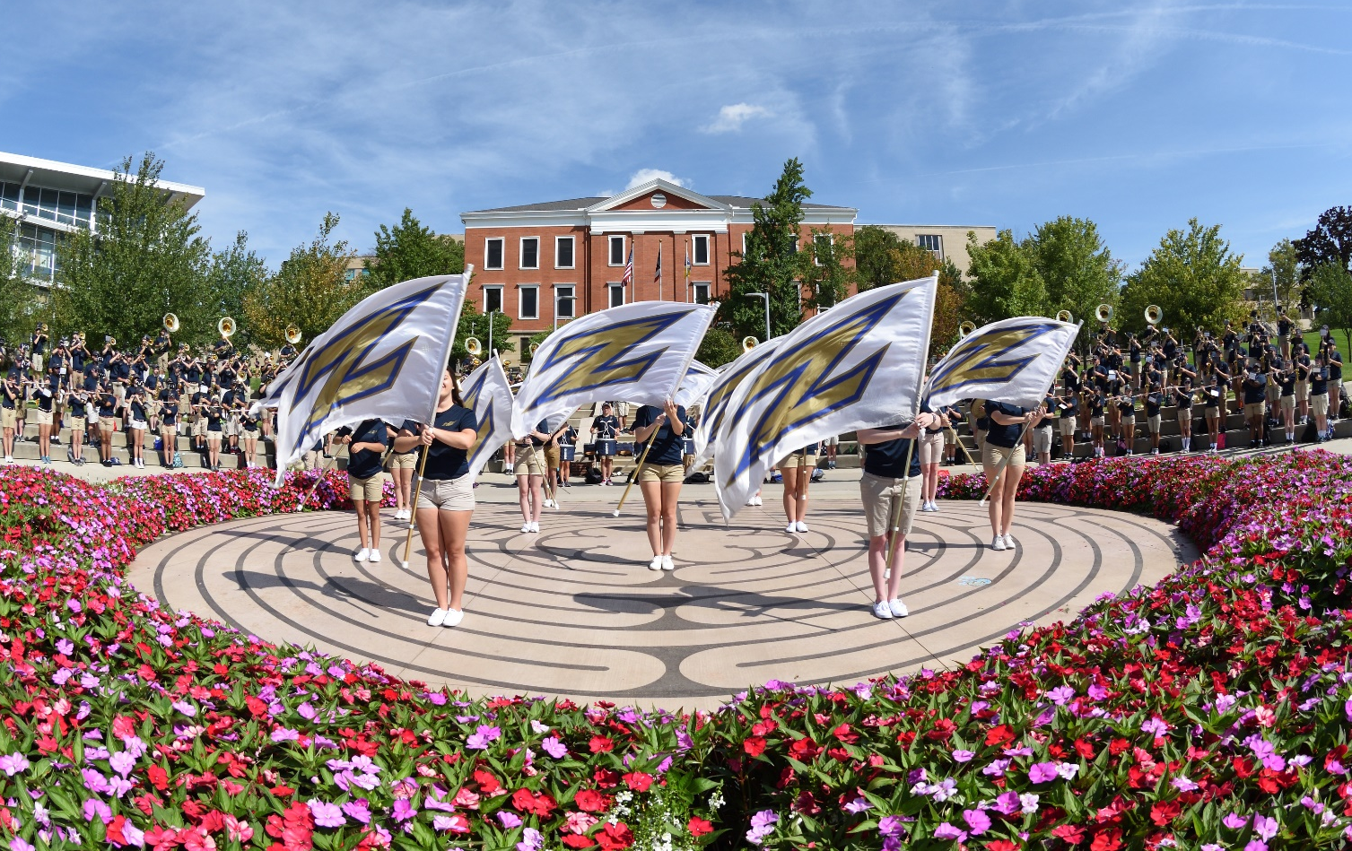

INTRODUCTION

The University of Akron provides financial support to graduate students for several reasons. In addition to assisting those qualified in the pursuit of graduate degrees, financial aid also recognizes and rewards scholarship and responsibility, extends the range of academic experiences, and assists departments and faculty in carrying out their academic and professional tasks. The term, graduate assistant, applies to those students under contract supported by university funds or external funds administered through The University. Graduate assistants have varied duties, which may include full teaching responsibility for undergraduate courses, conducting discussion sections, supervising laboratories, assisting faculty with research or assisting departments in various ways.

THE GRADUATE ASSISTANT

Graduate Assistant as Graduate Student

Graduate assistants (GAs) must juggle a number of related roles. At the same time that they are pursuing their own degrees, they also function as instructors, tutors, student advisers, researchers or administrative assistants. Time management and planning are essential; setting goals and ordering priorities are crucial. Above all, graduate assistants must plan and manage their time so they are able to perform their duties as graduate assistants while they remain focused on their primary academic goals as graduate students.

Graduate Assistant Orientation

The Graduate School sponsors an annual graduate assistant orientation. Many departments also offer orientations of their own for students entering their programs; these are designed to provide specific information about programs and graduate assistantship assignments. All graduate assistants must be available to attend any orientations required by the college, department/school, Graduate School or International Center. Orientations are generally held the week prior to the start of fall semester.

Graduate Assistant Supervision

Graduate assistants are supervised in their work assignments by the unit in which their work is performed. For teaching and research assistants, the supervisor normally is a faculty member. Administrative assistants may be supervised by either faculty or staff members. Since the primary purpose of graduate assistantships is to provide graduate students with academically relevant experiences, it is the responsibility of the supervisors to assure that this occurs.

TYPES OF AWARDS/APPOINTMENTS

Graduate Assistantships

Graduate assistants may be appointed as teaching assistants, research assistants, or administrative assistants. Appointments provide a basic stipend and/or tuition scholarship. The type of award may vary by college and academic unit and include both full-time (20 hours/week) and part-time (10 hours/week) appointments.

Teaching/Laboratory Assistantships

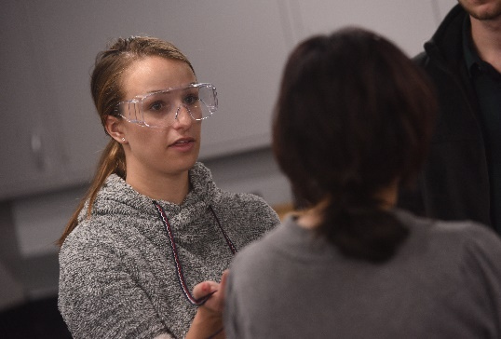
Teaching assistants participate in undergraduate instruction by teaching and providing support services. Teaching assistants may serve as the instructors of record, laboratory assistants, discussion or recitation leaders with grading and office hour responsibilities. It is expected that this experience will relate to and facilitate the completion of degree requirements and also provide teaching experience relevant to a professional career.

Research Assistantships
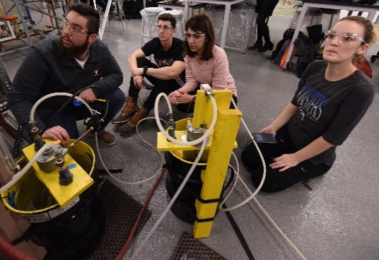
Research assistants are assigned to participate in research or research-related tasks directed by faculty members. In addition to university-supported research assistantships, some awards are made available by individual faculty through grants from industry and government agencies. These experiences are required to be educational and provide insights into the way in which research is conducted.

Administrative Graduate Assistantships

A limited number of administrative graduate assistantships are available. Administrative graduate assistants are assigned to participate in the administration, development, or service activities of the appointing unit. Both academic and non-academic units use administrative assistants. All funding for administrative assistants must come from the appointing unit. These appointments are meant to provide benefits to students and to the appointing units. Administrative assistants should have the opportunity to learn both office functions and educational management procedures.

Tuition Awards

A limited number of tuition awards are available. Awardees receive partial remission of tuition but no stipend. These awards are for first year graduate students and require service to the university that aligns with university-identified strategic areas of need. These are two-semester, non-renewable awards and may not cross fiscal years. These are not considered graduate assistantships.

TERMS, CONDITIONS AND BENEFITS OF ASSISTANTSHIPS

Offers and Acceptances

April 15th is the deadline for the extending of and the acceptance of assistantship offers. The University of Akron adheres to the Council of Graduate Schools Resolution Regarding Graduate Scholars, Fellows, Trainees and Assistants which, in brief, states:
- If a student accepts an offer before April 15th but subsequently wishes to withdraw, the student may submit a written resignation any time through April 15th

- If a student has an acceptance in force after April 15th, the student is committed to obtaining a written release before accepting an offer at another institution.

- An offer extended by an institution after April 15th is contingent upon submission by the student of written evidence of release from any previously accepted offer.

The responsibility for compliance with this resolution rests with the academic departments making the awards and the students accepting them.

Eligibility

To be eligible to receive a graduate assistantship award, a student must satisfy all the requirements listed below. Individual departments may impose more stringent requirements at their discretion. A student is not eligible to hold an assistantship in an academic department to which they have been denied. To be minimally eligible for consideration, a graduate student must:

- Gain admission to a graduate degree program
  - Only fully-admitted graduate students are eligible for GAs – this includes TAs and RAs
    - Provisionally-admitted and conditionally–admitted students are not eligible for GAs
    - Once provisional and conditional students satisfy full admission requirements, they are eligible for GA consideration in the next semester
- Maintain graduate enrollment as a full-time student
  - All GAs must be enrolled full-time in any term in which they are provided a stipend
    - Students must be enrolled by the first day of the semester and for the entire semester in any term they receive support, or are subject to repayment
  - Full-time enrollment is a minimum of 9 hours during the fall and spring terms and 6 hours during the summer term
    - 6 hours in the summer does not satisfy the university’s definition of full-time enrollment (9); 6 hours is the minimum required to hold a summer GA contract
    - International student GAs must also conform to enrollment requirements of their international status; international students should consult with the International Center to ensure they are in compliance
  - The most remission any GA is provided by the Graduate School is 12 hours during the fall and spring terms and 6 hours during the summer term – provided the program has sufficient allocations to cover these amounts
    - Tuition remission cannot be banked; it must be used in the term in which it is provided
    - Tuition remission is provided for courses in the student’s plan of study only
    - Tuition remission may not be used for undergraduate courses
- Maintain a minimum cumulative graduate grade point average of 3.00
  - Please see Section - Academic Performance
- Show satisfactory progress toward completing degree objectives, as defined by the department
- Perform graduate assistantship duties satisfactorily, as defined by the immediate supervisor and/or academic unit
- Maintain appropriate standards of academic conduct
- Honor the terms of the contract agreement
- Meet oral proficiency requirements (Teaching Assistants)
  - Please see Section - Oral English Proficiency Assessment

For students to be paid by the first date of their contract, the completed contract must be in the Graduate School at least three weeks prior to the start date of the contract (excluding campus and national holidays).

Academic Performance

- Good Standing
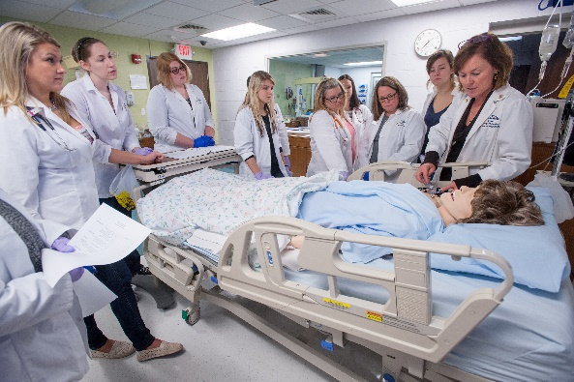
- A cumulative GPA of 3.00 or better in all graduate coursework for each semester the student is enrolled
- A cumulative GPA of 3.00 or better is required for graduation
  - Significant digits are employed in enforcing probation and graduating GPA
- Probation
- Any graduate student whose cumulative GPA falls below a 3.00 is considered to not be in good standing
- The student is placed on probation and notified by the Graduate School
- Getting off probation
- Full-time students have two consecutive semesters (excludes summer) to return to good standing
- Part-time students have 15 graduate credit hours to return to good standing
- Graduate Assistant Probation
- Graduate assistants may retain their assistantships for the two consecutive semesters while returning to good standing; anyone not returning to good academic standing will be subject to dismissal and will not be eligible for Graduate School support (this includes TA-stipend and any GA-remission)
- A graduate assistant that is on probation a second time is no longer assistantship-eligible and will lose their assistantship at the end of the semester that qualifies them for probation, a second time. This is regardless of whether or not the student was able to return to good standing within 1 or 2 semesters of funding
- Academic Dismissal
- Any graduate student will be subject to dismissal for the following reasons:
      - Failing to return to good standing following probation
      - A second probation period
      - Failing to make satisfactory progress toward degree completion
      - Accumulating 6 semester credits of ‘C+’ or lower
      - Accumulating 6 semester credits of ‘F’ will result in mandatory dismissal
        - Grades of ‘D+’, ‘D’, and ‘D-‘ are equivalent to ‘F’ at the graduate level
- Readmission
- Any graduate student dismissed from the Graduate School for academic performance may reapply after one year, provided there is evidence to support an expectation of satisfactory performance
      - No form / generally addressed via email statement
- Repeating Courses
- Any graduate course may be retaken once for credit
- Grades and credit hours for all repeated courses will remain transcripted and contribute to GPA
- Courses in which a ‘D’ or lower (‘D+, ‘D’, ‘D-‘ or ‘F’) is earned, must be repeated if required for the degree

Oral English Proficiency Assessment

Assessment of oral English proficiency is required by Ohio law and must be certified before teaching assistant duties can be performed. Prospective teaching assistants must achieve a minimum score of 23 on the Speaking Section of the internet-based TOEFL (see http://www.ets.org/toefl), or a minimum score of 7 on the Speaking Section of the IELTS (see https://www.ielts.org/). Teaching assistants provide an important contribution to the education of our undergraduates. As such, all teaching assistants are held to a higher English proficiency than that required for admissions. Non-native English-speaking TAs must be vetted based upon testing. There will be no exemptions. A copy of the test score must be submitted to the Graduate School with the contract before the contract can be processed.

Verification of Employment Eligibility and Identity (Form I-9)

The Immigration and Control Act of 1986 requires all employers to verify each new employee’s identity and employment eligibility. The employing department has the responsibility for completion of the Form I-9 for each new domestic graduate assistant; the International Center has the responsibility for completion of the Form I-9 for each new international graduate assistant.

The Form I-9 is to be completed within three working days of the effective date of the Agreement/Appointment form. Instructions for completion are on the reverse side of the form and documentation must be verified with the graduate assistant in person. The original, completed Form I-9 must be forwarded to the Graduate School with the Agreement/Appointment form or within three days of the effective date of the appointment. Paychecks will not be issued until the completed Form I-9 is received in the Graduate School.

Assistantship Funding Duration

Graduate School support is defined as stipend and/or tuition remission. The following are the maximum funding durations by degree level:

  - Master’s students are provided up to 2 years (total) of GA support from the Graduate School
  - Doctoral students are provided up to 5 years (total) of GA support from the Graduate School
  - Masters/Doctoral students are provided up to 5 years (total) of GA support from the Graduate School

Doctoral students who have exhausted Graduate School funding during their tenure (5 years) are not eligible for a 6th year of support. The mechanism to receive any support is to become a part-time instructor with some tuition remission. Students funded by a grant mechanism that funds their stipend into year 6, would be eligible for tuition remission from the Graduate School. A student may hold a graduate assistantship funded by the Graduate School for up to an accumulated 174 graduate credit hours if they do not hold a previous graduate degree from another institution. If a previous master’s degree is held from another institution then a student may hold a graduate assistantship, funded by the Graduate School, for up to an accumulated 140 graduate credit hours.

Renewals of Appointments

Renewal of appointment is not automatic. Reappointments are based on the availability of funding, department determination of satisfactory performance and department needs. Students may apply for reappointment through their respective departments. Students must meet departmental guidelines and deadlines for application.

Non-renewal

Graduate assistants, who fail to meet eligibility requirements, may be denied renewal. The department and the Dean of the Graduate School regardless of whether the Dean or the department head initiates the action will reach such a decision jointly.

Termination/Resignation Before End of Appointment

Graduate assistantship appointments are contingent upon and subject to satisfactory performance of assigned duties as determined by the appointing unit. Appointments may be terminated for cause before their expiration under certain conditions.

- Termination before end of appointment:

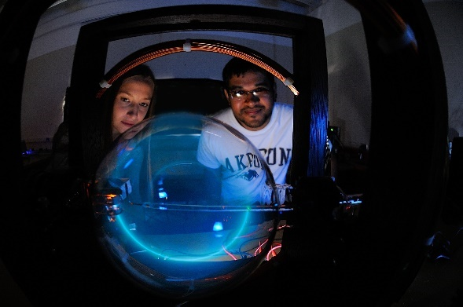
  - Appointee fails to perform services satisfactorily or violates laws or University regulations which in the judgment of the University affect duties or services performed by the appointee; or

  - Appointee violates provisions of Agreement/Appointment; or

  - Appointee fails to maintain good academic standing (3.00 minimum GPA); or

  - University funds cease to be available for graduate assistantships

Before termination for unsatisfactory performance, graduate assistants must receive from their immediate supervisors’ written notice of specific deficiencies in performance, as well as detailed suggestions for improvement. Graduate assistants should receive at least two written warnings with adequate opportunities in between to improve. Unit heads should be involved in this process. If unacceptable performance continues, and a decision is made to proceed with possible termination, then, in all cases, the chief administrative officer of the appointing unit must give the graduate assistant a pre-termination hearing. The hearing should consist of oral or written notice of the charges against the graduate assistant, an explanation forming the basis for the charges, and an opportunity to present reasons, either in person or in writing, why the termination should not take place. After these proceedings, the appointing unit should notify the Graduate School of the outcome.

- Resignation:

A graduate assistant may resign by voluntary mutual written agreement among the graduate assistant, the supervisor, and the head of the appointing unit. Written notification must be submitted by the appointing unit to the Graduate School indicating the last working day through which the graduate assistant is entitled to pay. It is the student’s responsibility to withdraw from classes.

Repayment of Graduate Scholarships Upon Resignation:

The Graduate Scholarship Recipient is not required to repay any scholarship award if he or she withdraws from all classes at the time of resignation. However, if he or she continues as an enrolled graduate student at The University of Akron after resignation from the scholarship award, then he or she must repay the scholarship based on a percentage of the number of weeks remaining in the semester or summer session.

Examples:

- If the student resigns in the ninth week of a 16-week semester, the repayment will be 7/16 or 44% of the fees required in that semester.

- If the student resigns in the second week of a five-week summer session, the repayment will be 3/5 or 60% of the fees required in that summer session.

All fee remission benefits cease upon award of the graduate degree toward which the support was provided.

Other Simultaneous Employment

Graduate assistants may not accept other full-time employment, either in or outside of the University. Graduate assistants, holding full-time (20 hours per week) appointments, may not accept other part-time employment in the University. Graduate assistants who want to work part-time outside the University, in addition to their assistantships, must have written approval from their department chair/school director (with a copy sent to the Graduate Dean). Such employment outside the University shall not exceed a total of eight hours per week while the University is in session. Holders of partial tuition scholarships are eligible to accept other full-/part-time employment, either in or outside the University, up to a total of 20 hours/week. CPT authorization is required for international students seeking additional employment.

Duties

Graduate assistants, with full-time appointments, shall provide 20 hours of service per week as assigned by the designated supervisor. Graduate students holding nine-month or twelve-month awards may, at the discretion of supervisors, be assigned to work during break weeks if this has been noted as a contingency in the contract. The supervisor will monitor the semester hours worked to be equitable to the total of the 20 hours required per week during the semester(s).

A limited number of non-service fellowship awards made available by faculty members from certain external funds may not carry a service requirement. Non-service fellowships are restricted to those from whom no service of any type is required. Tuition remission for recipients of graduate fellowships or scholarships that do not include a work requirement will be proportional to a minimum fellowship or scholarship award. Effective January 2017, the minimum GA stipend award required to receive full tuition remission is $5000 per semester. Note: Students must always be registered as full-time students to receive any scholarship, fellowship or assistantship.

Minimum and Maximum Credit Hour Enrollment Requirements

Graduate assistants and tuition scholarship recipients must enroll in a full-time program of graduate study at the University during each semester of appointment and retain that minimum for the entire semester/session. Full-time study is defined as nine graduate credit hours during fall and spring and 6 graduate credit hours during the combined summer sessions. The appointment may be rescinded if registration drops below these minimums. Graduate assistants holding partial assistantships must also maintain full time student status (9 graduate credit hours) and are financially responsible for any additional credit hours. Departments may establish a higher minimum, up to a maximum of 15 hours. Students holding 12-month, 10-week, 8-week, or 5-week summer session appointments must maintain a total minimum registration of six graduate credit hours over the combined summer sessions.

Stipends

The amount of money available for graduate assistant stipends is determined by the Board of Trustees of the University and is subject to change from year to year. Stipend amounts to the colleges are approved by the Provost. Stipend amounts to the academic units are determined by the Deans of the academic units. Stipend amounts to the students are set by the academic units with the approval of the Graduate School and may differ from unit to unit.

Tax Status of Stipends

The Internal Revenue Service (IRS) usually treats stipends paid to graduate assistants, as taxable income and the University is obliged to withhold income taxes. The Payroll Office will deduct appropriate Federal, State of Ohio and City of Akron income taxes.

Students should contact the IRS directly for tax information or consult their own tax advisers. The University of Akron does not provide tax consultation.

Payroll Procedures

Graduate Assistants must set up direct deposits to receive their paychecks. The directions and forms required are on the Payroll Office website at https://www.uakron.edu/controller/payroll-forms.dot. All first paychecks are available at the Payroll Office window in the Administrative Services Building (185 E. Mill Street) while the direct deposit is being set up.

An Employee’s Withholding Allowance Certificate (W-4), an Employee’s Withholding Exemption Certificate (IT-4), and the Employment in a Job Not Covered by Social Security From (SSA-1945) must be filed in the Payroll Office to allow proper tax deductions from payroll checks. Blank certificates are available in the Payroll Office. Graduate assistants must immediately report changes of address to the Payroll Office.

Payroll Exemptions during the Summer Session

For graduate assistants to be exempt from paying into one of the state retirement systems and Medicare during the summer, each student must meet the following requirements: Take 6 credit hours during the summer sessions total and not have a break in attendance that exceeds 5 weeks. The University’s five summer sessions extend over 13 weeks; therefore, the graduate assistant exemption will depend upon the session or combination of sessions attended.

Remission

The University of Akron shall provide tuition each semester or summer session of award period. Tuition remission is not provided for audit, undergraduate courses, courses outside of the students plan of study or fees. Graduate Scholarships will not be awarded, nor will any fee remission be applied, after the 14th day of any semester or session.

Tuition/Remission provided does not cover:
- Graduate general service fees
- Technology fees
- Library fees
- Course fees
- Facility fees
- E-Content fees
- Administrative fees
- Late registration fees; drop/add fees; re-enrollment fees; retroactive add for any course (this includes any courses added after the 14th day of any semester or session
- Thesis/Dissertation binding, or copyright fees
- Fines
- Parking
- Miscellaneous fees

Holidays/Vacation

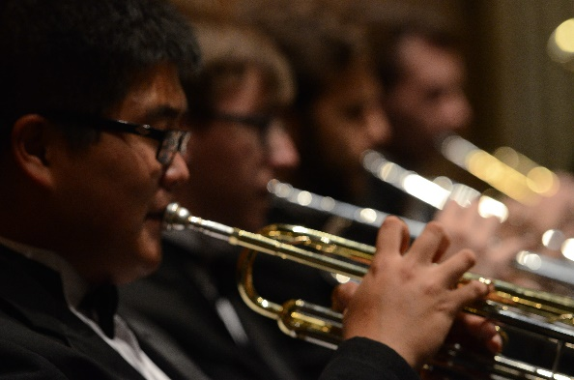
Graduate assistants do not earn vacation hours or accrue sick time. All Graduate Assistants may observe the University holiday schedule when offices are closed. Graduate assistants who hold academic year contracts will work while classes are in session, including exam weeks. Graduate assistants who hold any other type of contract will work from the start date to the end date of the contract, with the exception of spring break. Graduate assistants, with either an academic year contract or other dates (with prior written agreement from their supervisors) may be required to work during break weeks. Variations from this working schedule must be noted on the front of the graduate assistant contract as a contingency. The supervisor will be required to monitor the semester hours worked to be equivalent to the total of 20 hours required per week during the semester(s).

Leave of Absence

Graduate assistants may occasionally need to seek a leave of absence during the semester. The nature of the leave may be for personal, familial, medical, financial, or other compelling reasons. The following guidelines - Graduate Student Leave Request.pdf (uakron.edu) should be consulted when a graduate assistant is considering a leave of absence, either short-term (≤ 3 weeks) or long-term (> 3 weeks). Depending upon the type and duration of the request and the assistantship responsibilities, a leave approval is not guaranteed, particularly with respect to short-term requests that allow students to retain their assistantships. Students should make sure to communicate with their instructors and advisors to ensure leave requests follow the recommendations and note communication is key to approval while ensuring UA obligations are met and returns from leave are supported. These guidelines do not cover circumstances such as vacations and elective travels, but are for emergency leaves outside of a graduate assistant’s control.

Health Insurance

Graduate assistants are not covered by The University of Akron employee health insurance. They may, however use the Student Health Service, available to all students. Graduate assistants may purchase health insurance locally. International students are required to purchase health insurance. Inquiries may be directed to Health Services at 972-7808.

Worker’s Compensation

Graduate assistants are covered by Worker’s Compensation, which provides expenses for medical care and in certain cases loss of salary as well. The Industrial Commission of Ohio pays benefits for injury and/or disability resulting from the regular performance of official duties. Benefits may include compensation losses when disabilities extend beyond one week.

Retirement

Graduate Teaching Assistants who have a State Teachers Retirement System (STRS) account from any prior public employment are required to contribute to STRS, unless they have submitted an approved STRS exemption form to the Payroll Office. A GTA has 30 days from the start of the GTA appointment to submit the exemption form. All forms required are located on the Payroll Office website at https://www.uakron.edu/controller/payroll-forms.dot

PROCESSING OF ASSISTANTSHIP AND TUITION SCHOLARSHIP AWARDS

All agreement/appointment forms and scholarship/fellowship forms originate in the appointing department. Signatures should be affixed with a ballpoint pen. These forms constitute legal documents when properly signed by the Graduate School.

After departments have signed the forms they are forwarded to the Graduate School, checked for accuracy, and signed by the Graduate School. Contracts are not valid until the Graduate School has signed them. Copies are distributed to Human Resources, Payroll, the academic department, the appointing department if different, and the recipient. For international students, a copy of the signed agreement/ appointment form and/or tuition scholarship form are forwarded by the Graduate School to the Office of International Programs as evidence of financial support. All contracts should be in the Graduate School three weeks prior to the start date of the contract to ensure timely stipend payments.

RIGHTS AND RESPONSIBILITIES
Graduate assistants are subject to the rules and regulations of the Board of Trustees, the University and the departments within which they hold their awards. In the performance of their responsibilities they must abide by the academic and instructional criteria and policies established by the department in which they hold their appointments.

Graduate assistants shall respect the rights and opinions of students and uphold the academic standards of the University.

DIVERSITY, EQUITY AND INCLUSION STATEMENT

The University of Akron affirms the importance and value of diversity within the student body, and among our faculty, staff, administration and governing Board of Trustees. Our university values and respects the humanity of every individual from every background, and we embrace the diversity that defines UA and has so profoundly enriched our community.

ANTI-DISCRIMINATION & HARASSMENT POLICY

3359-11-13 Sexual Harassment Policy
-Date printed: October 25, 2020
(A) Statement of policy

(1) The university of Akron affirms its commitment to an academic, work, and study environment free of inappropriate and disrespectful conduct and communication. All students, faculty, and staff shall be protected under the guidelines of this policy.

(2) This policy shall be widely disseminated to employees and students and shall be incorporated into employee trainings and be included in student orientation materials. Supervisors shall ensure that those under their supervision are aware of the policy. The policy shall be available at the equal employment opportunity and affirmative action office, the office of student conduct and community standards and other places as may be specified by the chief human resource officer.

- By this policy, the university is providing notice that protected class-based harassment will not be tolerated. This policy will provide the basis for such concerns to be addressed.

(4) For purposes of this policy, protected classes are those specified in the affirmative action policy, paragraph (A)(2) of rule 3359-38-01 of the Administrative Code. These classes are race, color, religion, sex, sexual orientation, gender identity or expression, age, national or ethnic origin, disability, status as a parent during pregnancy and immediately after the birth of a child, status as a parent of a young child, status as a foster parent, military status, genetic information, or status as a veteran.

(B) Protected class-based harassment, including sexual harassment, violates state and federal laws. This policy shall be coextensive with such laws and prohibit unwelcome conduct directed towards a person based on their actual or perceived membership in a protected class where:

(1) Enduring the offensive conduct becomes a condition of continued employment or participation in the university’s educational program, activities or services, or

(2) The conduct is sufficiently severe or pervasive to create a work, educational or campus residential environment that a reasonable person would consider intimidating, hostile, or abusive.

(C) This policy prohibits retaliation against any student or employee for:

(1) Exercising their rights under this policy;

(2) Bringing forward a charge under this policy; or 3359-11-13 2

(3) Testifying, assisting or participating in any manner in an investigation, hearing or other proceeding under this policy or pursuant to procedures provided by law.

(D) Responsibility

(1) All persons affiliated with the university have a responsibility to implement this policy.

(2) The office of equal employment opportunity and affirmative action shall facilitate and administer this policy for employees consistent with the terms set forth herein and consistent with the state and federal rules, regulations, and laws governing this institution.

(3) The office of student conduct and community standards shall facilitate and administer this policy consistent with the code of student conduct for students and consistent with the state and federal rules, regulations, and laws governing this institution.

(E) Investigating reporting and procedures

(1) Any individual who feels that they have been subjected to protected class-based harassment by a university student, employee or a third-party at the university may file a formal complaint under this policy. The university reserves the right in its discretion to file a complaint to protect the university community. Complaints alleging that a university student has engaged in protected class-based harassment may be filed with the office of student conduct and community standards. Complaints alleging that a university employee or third-party at the university of Akron has engaged in protected class-based harassment may be filed with the office of equal employment opportunity and affirmative action. Such complaints should be filed as quickly as possible after the incident or conduct in question, utilizing either the informal or formal process.

(2) Any conduct defined as criminal under Title XXIX of the Revised Code must be resolved through the formal process. Such complaints may also be referred to the appropriate external agency, including the prosecutor, police, or other appropriate investigative agency.

(3) Formal complaints alleging protected class harassment by a student will be investigated and resolved in accordance with the code of student conduct. Formal complaints alleging protected class harassment by an employee or third-party will be investigated and resolved in accordance with the procedures adopted by the office of equal employment opportunity and affirmative action. Formal complaints alleging sexual harassment or gender-based discrimination will be responded to and investigated in accordance with the protocols approved by the title IX coordinator. The complainant and the respondent will be fully informed of the results of the investigation.

(4) Any student, faculty or staff person accused of protected class-based harassment is entitled to due process as specified in applicable laws, regulations, university rules, policies and/or or applicable collective bargaining agreements.

(5) Persons who violate this policy will be subject to appropriate corrective action, which may include, but may not be limited to, referral for counseling, written or oral reprimands, suspension or dismissal from the university, suspension with or without pay, termination, or referral to the criminal justice system. Sanctions for conduct prohibited by Title IX of the Education Amendments Act of 1972 will be in accordance with the protocols approved by the title IX coordinator.

(6) Any person found to have falsely filed a complaint under this policy will be subject to appropriate corrective action. A finding that there is insufficient evidence to substantiate a complaint is not the same as a finding that a complaint was falsely filed.

(7) Nothing contained herein shall be deemed to restrict or otherwise prohibit the complainant from filing a complaint with an appropriate external governmental agency, nor shall this policy be deemed as discouraging individuals from seeking legal counsel. It shall, however, be the responsibility of such individuals to meet any agency filing deadlines.

(F) Privacy

All complaints under this policy will be treated with discretion and be discussed only to the extent consistent with an appropriate investigation and response. Only those persons necessary for the investigation and resolution of the complaints will be given information about them, to the extent consistent with the university's legal obligations.

GRIEVANCE PROCEDURE

Complaints involving a graduate assistantship or tuition scholarship award should be brought to the attention of one’s immediate supervisor. If a solution is not reached at that level, the department chair/ school director should be consulted. Problems should be referred to the Dean of the Graduate School only if they cannot be resolved at a lower level.

Grievance Procedures for Graduate Students

Purpose
The procedures set forth in this document are intended to provide graduate students with a formal channel of appeal and redress of grievances arising out of their academic and/or employment relationship with the University.

Procedures
- Any graduate student who believes that they have valid grounds for a complaint shall attempt to resolve the problem through a conference with the faculty member involved, the department head, and/or the graduate advisor. Following that, the student may attempt to resolve the problem with the assistance of the academic dean. A graduate student presenting a case to the academic dean must provide a full written statement of the grievance, together with all appropriate supporting material. When or if the problem has not been adequately solved at that level or the student wishes to appeal that decision, the student shall prepare a written statement of the complaint setting forth clearly and specifically the allegations and shall hand deliver the written complaint to the Dean of the Graduate School. The Dean of the Graduate School shall notify the complainant confirming the receipt of the complaint and shall request all materials from the Dean of the complainant’s college.

- Within one week of receipt of the complaint, the Dean of the Graduate School shall communicate with all parties in an attempt to informally resolve the problem. The result of this process will be a recommendation by the Dean of the Graduate School which will be communicated in writing to all parties, including the Senior Vice President and Provost.

- The complaint shall become a grievance to be filed with the Senior Vice President and Provost if: 1) the Dean of the Graduate School wishes to have a Hearing Committee render a recommendation on the grievance; or 2) the student wishes to appeal the recommendation of the Dean of the Graduate School. The student must notify the Senior Vice President and Provost in writing within one week of notification of the Dean of the Graduate School’s decision on the complaint.

- Upon receipt of the grievance, the Senior Vice President and Provost shall notify in writing the President of Graduate Student Government that a Hearing Committee should be constituted. The Hearing Committee shall be organized in no more than two weeks.

- When the grievance has been filed with the Chairperson of the Hearing Committee, it shall be the responsibility of that Chairperson to notify in writing all parties involved in the grievance within two working days. This notification shall include the following information: that a grievance has been filed; the nature of the grievance; and the parties involved.

- If the charged party in that grievance admits the validity of the grievance, the Chairperson of the Hearing Committee shall waive the hearing and shall direct an appropriate resolution in consultation with the Hearing Committee.

- If the party charged in the grievance denies the validity of the grievance, the Hearing Committee shall conduct the hearing.

Hearing Committee: A Hearing Committee shall be established as follows:
- Chairperson – The Chairperson shall be a member of the graduate faculty with full membership, but not from a department involved in the proceedings. This Chairperson shall be selected by the Senior Vice President and Provost and shall serve for only one grievance proceeding. The Chairperson shall conduct the hearing and shall vote only in the case of a tie.

- Members – Four members shall be selected as follows:
  - From the complainant’s department – graduate student not directly involved, selected jointly by the Department Head and the President of the Graduate Student Government. If the grievance is filed against the Department Head, the Academic Dean shall substitute for the Department Head. If the grievance is filed against the department, the Senior Vice President and Provost shall substitute for the Department Head.
  - From the complainant’s department – a faculty member not directly involved, selected jointly by the Department Head and the President of the Graduate Student Government. If the grievance is filed against the Department Head, the Academic Dean shall substitute for the Department Head. If the grievance is filed against the department, the Senior Vice President and Provost shall substitute for the Department Head.
  - A graduate student not involved with the complainant and not from the complainant’s department, selected by the Vice Chairperson of the Graduate Council.
  - A member of the graduate faculty with full membership not involved in the complaint nor from the complainant’s department, selected by the Senior Vice President and Provost.

- A Hearing Committee shall be organized anew each and every time a grievance is brought forth. A Hearing Committee shall serve through the adjudication and resolution of the complaint.

Hearing Procedure:
- The hearing must take place within two weeks of the Hearing Committee’s formation.

- At least three working days prior to the hearing, the Hearing Committee Chairperson shall provide the Hearing Committee and the Parties involved with:
  - The student’s written statement of the grievance
  - Written notification of when and where the Hearing Committee shall meet
  - A copy of “Grievance Procedures for Graduate Students” and all relevant documents

- Each party shall be required to appear in person before the Hearing Committee to present their case. Each party may have an advisory/colleague present to protect their rights if so desired. However, the parties shall speak and act on their own behalf. Witnesses may be called to present evidence on behalf of the complainant or the charged person. The use of tape recorders is prohibited, except as may be required to accommodate persons with disabilities.

- All parties shall be entitled to an expeditious hearing. In urgent cases in which it is alleged that a regulation, administration decision, or action threatens immediate and irreparable harm to any of the parties involved, the Hearing Committee shall expedite the hearing and disposition of the case. The Hearing Committee is empowered to recommend to the Dean of the Graduate School that an individual, department, or college discontinue or postpone any action which threatens to cause irreparable harm, pending the final disposition of the case.

- The burden of proof shall be on the complainant and the standards of justice and fair play shall prevail in the adjudication of violations and grievances.

- If necessary, the Hearing Committee may consult with the University’s Office of General Counsel for advice at any time throughout this process

Decisions and Actions:
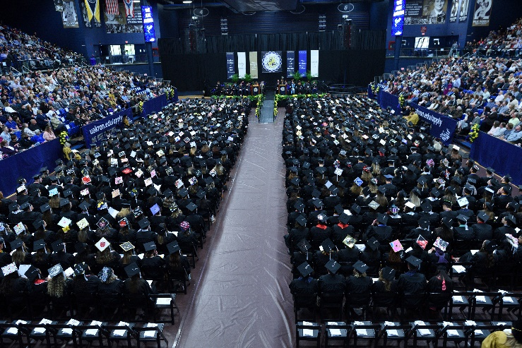
- The Hearing Committee shall decide as follows: there has been a violation of the complainant’s rights, or there has been no violation of the complainant’s rights.

- Should the Hearing Committee determine that a violation of the complainant’s rights occurred, the Committee shall, if practical, recommend a resolution to the Senior Vice President and Provost.

- The Senior Vice President and Provost, exercising their judgment, shall act on the implementation of the resolution recommended by the Hearing Committee.

Record Keeping:
The Chairperson of the Hearing Committee shall be responsible for keeping a summarized, written record of all the proceedings.

- Records of all proceedings shall be prepared by the secretarial personnel of the Graduate School. Copies of all proceedings shall be distributed as follows:
  - To all parties involved in the proceedings
  - To the Hearing Committee members
  - To the President of the Graduate Student Government
  - To the Dean of the Graduate School
  - To the Senior Vice President and Provost

- A copy of all proceedings shall be kept in the office of the Dean of the Graduate School pursuant to the University’s record retention proposal.

Appeal:
An appeal may be made to the President of the University after all of the above procedures have been followed. The President of the University shall assess each case on an individual basis and their decision shall be considered final.

QUESTIONS

Questions regarding graduate assistantship or scholarship awards should be addressed to the department to which application is made or in which an appointment is held. Policy questions may be addressed to the department or to the Graduate School.

Graduate School Staff:
Suzanne Bausch, PhD - Dean
Marnie Saunders, PhD (mms129@uakron.edu) – Interim Director
Heather Blake, MS (hblake@uakron.edu) – Administrative Coordinator
Deborah Phillipp, MEd (dphillipp@uakron.edu) – Director, Graduate Admissions and Student Services
Vivian Campbell, BS (vgc1@uakron.edu) – Director, Graduate Student Financial Aid and Budgets

TEACHING RESOURCES AT UA

Institute for Teaching and Learning

Do you have questions about your role as a graduate teaching assistant at The University of Akron? The University of Akron’s Institute for Teaching and Learning (ITL) supports graduate teaching assistants by providing resources focused on improving teaching and enhancing student learning. ITL offers workshops, information sessions, and training related to professional development, general education, student learning assessment, course design and development, and implementation of technology to enhance teaching. In addition to formal programming, ITL offers individual consultations designed to provide support and assistance with specific teaching related concerns. Check out the ITL website for more information on upcoming workshops and events: https://www.uakron.edu/itl/. You can contact ITL directly at: ITL@uakron.edu.

Online Learning Services

Do you have questions about Brightspace or designing your online course? Online Learning Services (OLS) is a small group of instructional designers and multimedia experts that is part of the Office of Academic Affairs. OLS is focused on helping all faculty (e.g., full-time, part-time, graduate teaching assistants) make the most of Brightspace. If you need a hand organizing your course, need help adding interactivity to your lectures or, want to create a fully online course; OLS is here to help. You can sign up for professional development opportunities (e.g., online teaching workshops) and one-on-one consultations with instructional designers at the OLS website: https://uakron.edu/learn/ols/index.dot or by emailing DDSHelp@uakron.edu.

CAMPUS RESOURCES (INFOGRAPHIC)

The Graduate School would like to thank Career Services and Student Employment for assistance in creating this infographic.

CAMPUS RESOURCES

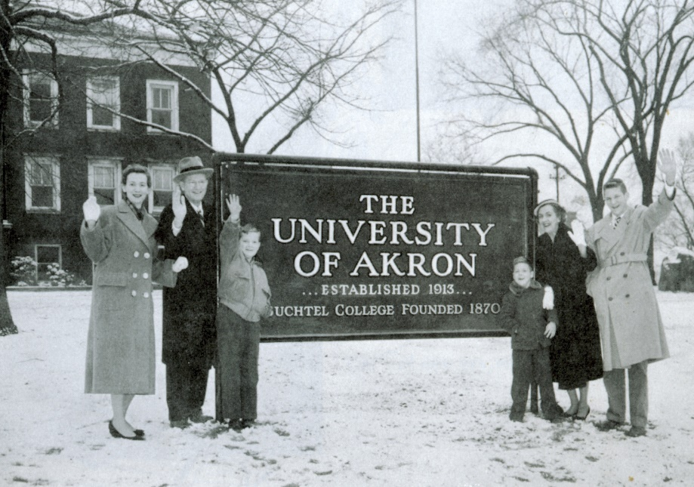
There are many valuable resources available to you through the Internet. General University information can be obtained from The University of Akron home page at The University of Akron : YOU BELONG HERE! : The University of Akron, Ohio (uakron.edu). Graduate School information is located at Graduate School | Home Page : The University of Akron, Ohio (uakron.edu). Payroll information can be found at http://www.uakron.edu/controller/. Please be sure to visit The University’s home page for complete and updated information.

Leigh Hall 515
gradsch@uakron.edu

