Coordinated Program in Dietetics Handbook

Academic Year 2022-2023

Coordinated Program in Dietetics Handbook
Table of Contents

Subject Page
Faculty Information
Dietetics Faculty 2

Coordinated Program Mission Statement and Goals
Mission Statement and Student Objectives 3
Program Goals with Outcome Measures 4

General Definitions in Clinical Activities 5
The Dietetics Profession
The Academy Membership and Registration 6
SAND and Scholarships 7
Code of Ethics for the Profession of Dietetics 8
RDN Credentialing Examination 8
Orientation Notes with Estimated Program Costs 9

Curriculum Information
CP Policies and General Information 11
Attendance and Punctuality 11
Professionalism 12
Physical Examination, Insurance/Injury 13
Background Checks / Drug Screens 13
Academics, Evaluations, Clinical Work 14
Disciplinary/Termination 15
Transportation 15
Curriculum Guide 15
Verification Statement 16
Annual Survey 16
Waiving Supervised Practice 16
Lines of Communication for Grievances 18
CP Health Insurance Form 19
Instructions for Health Information and Requirements Form 20
Name Pin Order Form 24
Tips for a Successful Supervised Practice 25
Program Knowledge Requirements and Competencies
Knowledge Requirements 2022 Standards 35
Competencies 2022 Standards 37

The University Of Akron Coordinated Program in Dietetics

Full-Time Faculty

ANZO, Patty 330-972-6755 SHS 210
MS, RD, LD, Visiting Associate Professor

LIU, Pei Yang 330-972-8842 SHS 210
PhD, RD, LD, Associate Professor

SCHAEFFER, Leann 330-972-6046 SHS 210
MA, RD, LD Associate Professor

SEHER, Christin 330-972-6322 SHS 210
PhD, RD, LD, Associate Professor of Practice

Various preceptors are responsible for supervising students in the Coordinated Program. You will meet them as you proceed through the rotations in your clinicals (supervised practice).

Program Goals, Objectives and Actual Outcomes

Goal #1- Graduates will have the skills and knowledge to practice as entry-level Registered Dietitian Nutritionists.

Goal #2- Graduates with an understanding of the need for continuing education, leadership, and service to all individuals globally.

A) ACEND Required Objectives  (Programs must insert a target measure in the objectives when one is not identified by ACEND) | B) Indicate the goal the objective measures (Insert the goal number: 1 or 2)
“At least 80% of program graduates complete program/degree requirements within 7.5 years (150% of the program length)”. (RE 2.3.b.1) | 1
“Of graduates who seek employment, 75 percent are employed in nutrition and dietetics or related fields within 12 months of graduation”. (2.3.b.2) | 1
”80 percent of program graduates take the CDR credentialing exam for dietitian nutritionists within 12 months of program completion”. (2.3.b.4.a) | 1
“The program’s one-year pass rate (graduates who pass the registration exam within one year of first attempt) on the CDR credentialing exam for dietitian nutritionists is at least 80%”. (2.3.b.4.b) | 1
The program will achieve a 75% employer satisfaction with graduate preparation for entry-level practice within one year of employment via survey using a 5-point Likert Scale with the opportunity to provide rationale for any responses not posted as the highest score. Employer satisfaction will be a rating of 4 or 5 on the Likert Scale. (2.3.b.3) | 1

Program Specific Objectives: Each program is expected to align at least one objective developed by the program to each program goal. Enter your program specific objectives here and indicate which goals they align with.

A) Program Specific Objectives | B) Indicate the goal the objective measures (Insert the goal number: 1 or 2)
The program will achieve a 75% graduate satisfaction with graduate preparation for entry-level practice within one year of graduation via survey using a 5-point Likert Scale with the opportunity to provide rationale for any responses not posted as the highest score. Graduate satisfaction will be a rating of 4 or 5 on the Likert Scale. | 1
75% of graduates surveyed will demonstrate their leadership by becoming preceptors, clinical instructors, officers in their local, state, or national dietetic associations, or assisting in securing grants that provide services to a diverse population within 1 year of graduation. | 2
50% of graduates surveyed one year after graduation will be engaged with culturally diverse populations or in culturally diverse settings through employment, volunteering or civic/community activities. | 2

General Definitions

Role Model
A person in active practice who shares his/her duties, experiences and concerns with a student

Attachment Learning
Placement of a student with clinical personnel who continue normal duties, act as a role model, and guide student experiences. The following is a brief resume of expectations. For clarification, see job descriptions of Clinical Instructor, Preceptor and Clinical Staff, and Intern

Clinical Instructor (Role Model)
Part or full time faculty member who collaborates with the staff in the clinical area for the interns, assigns intern work schedule, serves as liaison for communication between the university, clinical coordinator, and clinical staff. Collaborates with preceptor in establishing procedures and activities in the supervised practice area for the intern. Grades all papers, case studies, projects. Evaluates intern performance.

Preceptor (Role Model)
A person in active practice who serves as a role model and as a liaison between the University and clinical staff in the guidance of intern experiences.

- Collaborates with the clinical staff in establishing procedures and activities in clinical area for the interns.
- Assigns work schedule for students that correlates with the department's usual activities
- Serves as liaison for communication between University, clinical instructor, clinical staff, and intern – on site professional.
- Correlates and submits intern evaluations after reviewing with the intern.

Clinical Staff (Role Models)
- Shares experiences and allows the intern to participate in usual activities as much as possible (may request student to perform an activity).
- Communicate problems that may arise to intern and instructor.
- Perform as informal professional advisors.
- Provide input for intern evaluation.

Intern
  - Performs assigned duties, as requested, in a professional manner.
  - Makes "professional use" of time in the clinical area

The Academy Membership and Registration

Accreditation
The Coordinated Dietetic Education Program (CP) is accredited by the Accreditation Council for Education in Nutrition and Dietetics (ACEND) of the Academy of Nutrition and Dietetics (The Academy). To maintain accreditation status, a Progress Report, indicating substantial compliance and a summary of procedures for the Coordinated Program, is submitted to ACEND for approval. Periodic self-studies and site visits are required for accreditation.

Student Membership in The Academy
Students in dietetic programs at accredited colleges/universities are eligible for Membership in The Academy. Membership in The Academy is required for CP students. Dues include subscription to the Academy Journal, daily news updates, and weekly public policy notices. Applications for membership are available in the Nutrition Center.

Information about the Academy is available from your program director or through: The Academy for Nutrition and Dietetics
120 South Riverside Plaza, Suite 2000
Chicago, IL 60678-7215
800.877.1600
www.eatright.org

Routes To Membership in The Academy
Successful completion of the Coordinated Program (CP) accredited by ACEND with clinical experience in management, Medical Nutrition Therapy, and community nutrition provides graduates with eligibility for membership in the Academy.

The Academy's Mission
ACEND® ensures the quality of nutrition and dietetics education to advance the practice of the profession.

The Academy's Vision
ACEND® is valued for advancing excellence in nutrition and dietetics education.

The Academy's Values
- Objectivity
- Integrity
- Accountability
- Respect

The Academy's Goals
To achieve its mission and vision, the ACEND® board has established strategic goals.
- Assures the quality of nutrition and dietetics education through a peer review process.
- Effectively communicates the accreditation process and expectations.
- Fosters innovation in nutrition and dietetics education.

Student Academy of Nutrition and Dietetics

The University of Akron’s Student Academy of Nutrition and Dietetics (SAND) provides dietetic students with an excellent opportunity to utilize leadership and organizational skills and to market good nutrition across campus and the local community. It also is a fun way to meet people, make new friends, and to network with dietetics professionals. Even though CP is demanding of your time, the faculty strongly encourages you to actively participate in the SAND.
Serving as an SAND officer is an excellent example of your dedication and leadership. This service reflects positively on you and will benefit your applications for scholarships and future employment.

Greater Akron Academy of Nutrition and Dietetics
OR

Greater Cleveland Academy of Nutrition and Dietetics

The Greater Akron Academy of Nutrition and Dietetics (GAAND) is the local professional dietetics organization in Akron. Dietetics students are strongly encouraged to become members of this association and to participate in its many meetings and activities. Membership applications can be obtained by contacting GAAND directly. You must be a member of The Academy to hold membership in GAAND.

The Greater Cleveland Academy of Nutrition and Dietetics is the local professional dietetics organization in Cleveland. Cleveland area students are encouraged to become members of this association and participate in its many meetings and activities. Membership applications can be obtained by contacting GCAND directly. You must be a member of The Academy to hold membership in GCAND.

Scholarships
Scholarships are available to members from SAND, GAAND, GCAND, Ohio Academy of Nutrition and Dietetics (OAND), The Academy, the Nutrition and Dietetics Advisory Board and various other sources throughout the year. Information regarding scholarships will be posted on the Nutrition Brightspace Page. Deadlines for applications will vary but most are considered during the spring semester. To apply for scholarships, students must:
- Complete application forms
- Request required letters of recommendation from faculty well in advance of deadlines
- Submit all materials before the deadline date

Code of Ethics for the Profession of Dietetics:
The Academy of Nutrition and Dietetics and its Commission on Dietetic Registration have adopted a voluntary, enforceable code of ethics. This code, entitled the Code of Ethics for the Profession of Dietetics, challenges all members, registered dietitians, and dietetic technicians, registered, to uphold ethical principles. The enforcement process for the Code of Ethics establishes a fair system to deal with complaints about members and credentialed practitioners from peers or the public.

The Ethics Committee of the Academy is responsible for reviewing, promoting, and enforcing the Code. The Committee also educates members, credentialed practitioners, students, and the public about the ethical principles contained in the Code. Support of the Code of Ethics by members and credentialed practitioners is vital to guiding the profession’s actions and to strengthening its credibility.

The Code of Ethics was revised and approved on June 1, 2018.
Code of Ethics available at https://www.eatrightpro.org/-/media/eatrightpro-files/career/code-of-ethics/coeforthenutritionanddieteticsprofession.pdf?la=en&hash=0C9D1622C51782F12A0D6004A28CDAC0CE99A032

RDN Credentialing Examination
Graduates are eligible to take the registration examination for dietitians (RD exam) after successful completion of CP. The computer-based RDN examination is conducted at centers designated by the Commission on Dietetic Registration. Information is provided during the second year of the CP.

ORIENTATION NOTES

- CP at The University of Akron
  - Established in 1975
  - Recognized and supported by local communities and state
  - One of three CPs in Ohio, about 60 in the country.
  - You are joining a prestigious group of individuals who have been selected for and successfully completed CP. Since 1977 approximately 470 students have completed CP.

- CP vs Dietetic Internship
  - You have been selected through a rigorous selection process but that does not mean that you are necessarily any more qualified than students who choose to follow the traditional route.
  - More will be expected of you during this experience because of the program requirements.

- Costs
  - CP estimated program fees – in addition to tuition, housing and The University of Akron fees:
Career Decisions in Nutrition | 5.00
Nutrition Fundamentals | 86.73
Food Science Lecture | 100.00
Food Systems Management I | 15.00
Food Systems Mgmt I Clinical | 20.00
Medical Nutrition Therapy I | 25.00
Med Nutr Therapy I Clinical | 55.00
Nutrition Commun & Educ Skills | 25.00
Advanced Food Preparation | 75.00
Food Systems Management II | 5.00
Nutrition in Life Cycle | 10.00
Medical Nutrition Therapy II | 25.00
Med Nutr Therapy II Clinical | 120.00
Nutrition Assessment | 20.00
Med Nutri Therapy in LT Care | 50.00
Senior Seminar | 10.00
Community Nutrition I | 35.00
Community Nutrition I-Clinical | 40.00
Community Nutrition II | 20.00
Staff Relief: Dietetics | 50.00
Sports Nutrition | 86.73
Practicum in Dietetics | 10.00
Professnl Preparatn- Dietetics | 70.00
Nutrition Commun & Educ Skills | 25.00
Advanced Food Preparation | 75.00
Nutrition in Life Cycle | 5.00
Nutrition Assessment | 15.00

- Additional Fees
First Year
Name Pin | $10
Physical | $50-$100
Second Year
RD Exam Workshop | $300-$400

Both years:
TB Tests and flu shots annual | $80
Transportation and parking fees | $500-$1,000
Books | $500-$1,000
Drug Screens (if applicable) | $65
Membership in the Academy | $50

- Important points to ponder
  - Commitment to program – faculty want you to succeed.
  - The faculty is here to help you, encourage you, teach, guide, and mentor you but not to decide your future. You control your destiny and control your personal and professional growth over the next two years.
  - Professionalism – dress, look, talk, think PROFESSIONALLY.
  - You are a student (intern)– not peers of faculty members, preceptors, etc. It is inappropriate to address faculty by their first names.
  - Clinical facilities and preceptors devote many hours to your education. They do this for free. Without our clinical placements and preceptors we would not have a Coordinated Program.
  - Remember your behavior, attitude, and work ethic not only affects you but future students in the program. It also is a reflection of the faculty and Coordinated Program at The University of Akron.

It is all up to you. You can do this and be successful.

Policies and General Information for the Coordinated Program (CP) in Dietetics

The Coordinated Program is an accredited, concentrated program that coordinates clinical experiences with classroom lectures during the last two years of the dietetic program. A concerted and cooperative effort is encouraged, on the part of clinical staff as well as faculty, to stimulate in students a desire to discover resources and answers to many of their own questions.

The future of this program depends on the support and cooperation of each health-care or community agency. Please be advised that critical and/or judgmental comments made directly to clinical staff reflect upon you, personally, as well as on the program. Recommendations and comments from the preceptors, regarding the quality of your participation are shared with other professionals with whom you may be seeking future employment.

Please always keep in mind that a positive attitude promotes learning and also makes your life more enjoyable. You are the only one who can control your attitude! Civility is expected at all times, whether in classes, clinicals, laboratories, or other group situations.

Each clinical site will provide different opportunities and when made available interns will be expected to fully participate in these opportunities. Additional opportunities may become available and you are encouraged to participate in these and, in fact, may be required to participate.

Retention in the program is dependent upon successful attainment of the following policies. Any exception to these policies will be explicitly explained to the student verbally and in writing.

POLICIES

ATTENDANCE AND PUNCTUALITY:
Participation in CP represents a specified number of hours in the classroom and clinical areas to meet the program accreditation requirements. Clinical hours provide the opportunity for supervised practice required by the program, to develop the entry-level competencies needed for registration eligibility and employment.

Therefore, the following policies related to attendance and punctuality are to be followed:
  - Attendance and punctuality (100%) in class and clinicals is expected unless excused for unusual circumstances by the instructor. This participation is imperative for the building of a sound foundation of theoretical concepts leading to competent professional performance in all areas of dietetics. Any time missed in clinicals will be made up at a mutually agreed upon time with the preceptor and clinical instructors.

- The academic agreement signed by you is a contract between you and the program. Hours for each rotation are listed on the academic agreement. These hours have been sent into ACEND for our accreditation. You MUST fulfill the minimum hours on the academic agreement in order to be considered for graduation from the program.

  - In case of illness and/or unanticipated absence, the intern is expected to notify the clinical (faculty) instructor, and clinical preceptor immediately. It will be necessary to make up any days that are missed in the clinical area in order to comply with contractual requirements of CP.

  - Attendance during times listed for clinicals on any given day are approximate and may vary. You may find that you need to be at clinicals longer than anticipated due to a schedule change. Flexibility is expected.
  - Interns may expect a weekend or evening experience to be scheduled, if appropriate for the agency.

  - Punctuality demonstrates self-responsibility and is expected for class, scheduled clinical experiences, field trips, or seminars. Please allow sufficient time for travel. Clinical hours for the program are minimal and every minute must count! In addition, you may be creating a good impression on a future employer. If you must be absent for class, you must notify the instructor prior to the start of the class.
  - Interns will be required to attend pertinent educational seminars as they arise, for which registration fees may be required. The intern's time must be flexible, as some experiences and field trips may be scheduled on short notice. Transportation to these seminars, as well as to clinical facilities, will be the responsibility of each intern, and punctuality is expected. Parking passes for several of the hospitals may be available. Professional dress (no jeans) is usually worn on field trips.
  - Students are expected to attend professional meetings/conferences as assigned throughout the two-year program. If an intern is absent due to an emergency, alternate arrangements must be made with the instructor. The student may be required to research and present a related topic to classmates as assigned by instructor or to substitute another professional meeting(s), if approved by instructor.
  - If the University is closed due to inclement weather before the intern is due at the assigned facility, he/she will not be expected to attend clinical. Please notify the preceptor and the faculty instructor. If the University closes after the intern arrives at the clinical site, the intern should work for the time period determined by the preceptor.
PROFESSIONALISM:
    - Professional dress for Food Systems Management includes: clean, pressed khaki pants of respectable fit and length, a top with a collar, lab coats, appropriate hose or socks, rubber soled walking shoes (cleaned daily) or substantial “duty” shoes, no nail polish, or jewelry. (Only watch, wedding band and post-earrings). Hairnets must be worn in areas where food is present. (Plastic gloves, provided by the facility, are usually required when handling food).
    - For community, health and wellness clinical sites, and medical nutrition therapy clinical sites, clean, pressed clothing and jewelry appropriate for professional persons working in a business office is expected. Respectable fit and length of dress or pants is expected. No pierced nose, eye, or tongue jewelry is allowed. Tattoos should be covered. If you are unsure of required professional dress, ask your clinical instructor.
    - Name pins with your name and title “Dietetic Student” are required as part of the professional dress and may be purchased at The University of Akron Bookstore. Verification of spelling and payment is made when name pins are ordered. Name pins are to be worn in all clinical settings.
    - Second year CP students - interviews for potential jobs after graduation must not be scheduled during class or clinical! It is neither professional nor ethical for you to conduct interviews during the time allotted for supervised practice.

    - Other attire cannot be worn in kitchens of the clinical sites due to safety and sanitation hazards. This attire may be worn during community or nutrition in medical science rotations with the permission of the coordinator, clinical instructor and the preceptor.

    - When guest speakers present in classes, it is expected that you will wear professional dress to class.

PHYSICAL EXAMINATION, INSURANCE, INJURY:
  - Evidence of health insurance and a physical examination are required to participate in clinical settings. The physical examination, preceding clinical experience, must include an annual two step TB skin test or chest x-ray, Hepatitis B series, updated MMR and tetanus booster. Proof of required vaccinations is mandatory. Some facilities are requiring a titre for proof of vaccination.

  - A two-step TB test will be required prior to the start of the fall semester for the second year as well.

  - Most health care facilities are requiring influenza vaccinations. The student should plan on obtaining a vaccine as required.

  - Liability insurance is required and will be provided by the university blanket policy through course fees for 7760:310 (Food Systems Management I) and 7760:480 (Community Nutrition I). The CP Director arranges this through the university. Once the fee has been paid, the policy runs from January through December (12 months).

  - In the case of injury or illness while on the way to or from the supervised practice location, interns should seek medical care if needed and notify the authorities if appropriate. Neither The University of Akron nor the Coordinated Program assumes legal responsibility for or obligation for medical or legal services provided.

  - In the case of injury or illness while at the supervised practice location, interns should report to the Emergency Room, clinic, nurse’s office, or other health service if available. If not available, interns should follow the policy of their individual health insurance provider. Neither The University of Akron nor the Coordinated Program assumes legal responsibility for or obligation for medical services provided.

BACKGROUND CHECK, DRUG SCREEN
All Coordinated Program interns will be required to submit BCI and FBI fingerprint (background) checks for placement in clinical sites. Information on obtaining fingerprints will be provided by the CP Director. Fingerprints are to be completed both years of the program.

  - Background checks are sent to the Director of the Coordinated Program not the Ohio Board of Dietetics.

  - Some facilities may require that interns submit a drug screen. The intern is responsible for payment of the drug screen and for securing a drug screening facility.

ACADEMICS, EVALUATIONS AND CLINICAL WORK:
  - Curriculum Guides and CP by Semester are available on the CP Web Site Page or in the Undergraduate Bulletin.

  - For CP students, all courses coordinated with a clinical (supervised practice) are required. Those courses are Food Systems I, Community Nutrition I, and Medical Nutrition Therapy I and II and Health and Wellness Clinical. Clinical hours will be recorded in Typhon.
  - Interns should arrange to discuss major objectives with preceptors during the first week of clinicals, before the schedule for subsequent weeks is finalized.

  - Class assignments and/or clinical projects are not to be completed during clinical time unless specific approval is granted by the preceptor/instructor.
  - Student work in clinical sites may not be used to replace employees at the facility.
  - Weekly reports, projects, case studies, etc. are required in CP. Effective writing skills are imperative. In evaluating your writing your instructor may require you to re-write your work and/or may refer you to the writing lab for assistance. You are required to use Journal of the Academy of Nutrition and Dietetics reference style for all papers in dietetics.
  - Evaluation sessions are scheduled at the end of each term, and at any other time deemed necessary by student, faculty or clinical preceptor. After the second semester of the first year the CP faculty will conduct a total evaluation of each student's academic achievement, personal attitudes and ethics, professional involvement, contribution to the program, and in general the ability to demonstrate high quality standards required by The Academy. A majority rule of faculty will be sufficient to recommend remedial work prior to the student continuing in Coordinated Program.
  - Students may have access to their files with clinical evaluations at any time.
  - Re-evaluation of written clinical assignments: In courses which are team taught, re-evaluation by a second instructor is possible if the following criteria apply: 1) if original grade is C- or lower, and 2) if the request is brought to the Director of the Coordinated Program within one week after the assignment was returned. A second instructor to grade the assignment will be randomly assigned from among the faculty teaching the specific course. The revised grade will be an average of the two grades.
  - For continued participation in the CP program and to receive the verification statement, students must maintain a 3.0 GPA each semester and earn a minimum grade of "C" (2.00) or "Cr" in the courses listed in the Dietetics H40500BST Coordinated Program Curriculum Guide.

  - For supervised practice courses, the student’s academic work must be equivalent to a B (3.00) in order for the student to receive credit for the supervised practice. If you do not receive credit for the supervised practice, you will be dismissed from the Coordinated Program. You may complete the Didactic Program.
  - Because students are unable to have identical experiences and will observe a variety of techniques used in accomplishing similar goals, the post-clinical conferences provide students an opportunity to share their experiences and to learn from one another. Your attendance at pre- and post-clinical conferences is required.

  - Although a student may elect to work while enrolled, it is difficult to do justice to this educational opportunity concurrently. "Incompletes" in courses will be given only under very extraordinary circumstances, and only when the student has been doing acceptable work.
  - Academic support for students is available free of charge including writing labs, study skills lab, and tutorial services. Help a Zip can be used to report if you are having academic, mental, or financial concerns. https://www.uakron.edu/audiences/current_students/academic_resources.dot
  - Books purchased initially, while costly, will be used over a two-year period and will form the nucleus of the student's professional library. Your books are the basis for preparation to sit for the RD exam. DO NOT SELL BACK YOUR TEXTBOOKS - YOU WILL NEED THEM IN THE FUTURE. DO NOT RENT YOUR TEXTBOOKS. Workbooks and handbooks are also required for some courses. The nature of CP is that above-normal expenditures for transportation, textbooks are necessary.

DISCIPLINARY POLICY:
    - Students are advised to become aware of and follow the Student Conduct and Community Standards located on The University of Akron web site at www.uakron.edu/studentconduct.

ACADEMIC TERMINATION POLICY:
    - Students who do not receive a passing grade (B) on their clinical will be terminated from the CP immediately.

    - Students who do not receive a C or better in the didactic component of the program will be terminated from the CP.

    - Grievance procedure is on page 19 of the Coordinated Program in Dietetics Handbook.

    - Student group concerns must be submitted one week in advance for inclusion on the agenda at the dietetic faculty meetings. Students may be represented on all decision - making committees of the program as appropriate for student input. They may also be actively involved with curricular development, evaluation, and revision of the program. Individual student concerns should have prior review by the appropriate faculty member.

WITHDRAWAL AND REFUND OF TUITION AND FEES
- If a student is dismissed or chooses to quit the program, refunds of tuition and fees will be determined by the registrar. registrar@uakron.edu

TRANSPORTATION:
  - Reliable transportation to all clinical sites, seminars, and field trips is the responsibility of the student. Often parking is free at these sites. However, if this is not the case, the student is responsible for the cost of parking.

  - Neither The University of Akron nor the Coordinated Program is liable for accident or injury in transportation to and from supervised practice locations.

CURRICULUM GUIDE:
- The Coordinated Program Curriculum Guide and Suggested Sequence of Courses can be found on the Coordinated Program web page.
VERIFICATION STATEMENTS
- Upon successful completion of the Coordinated Program students will receive a verification Statement provided by the Program Coordinator. Six copies are provided and the student should keep them in a safe location for future use.

RD EXAM AND SURVEY:
    - Upon satisfactory completion of the program each student is eligible to take the registration examination in dietetics. It is expected that graduates of the program will sit for the RD exam.
    - The completion of a survey by every CP graduate after approximately one year of employment is required in order to maintain accreditation status. This will provide information for program evaluation and planning. LICENSURE IN THE STATE OF OHIO
    - In order to practice in the State of Ohio, a license issued by the Ohio Board of Dietetics is required
    - Graduates may obtain a limited permit to practice after graduation and you have sent your official transcript to the Board, but have not taken/passed the RD exam
    - Graduates may obtain a permanent license to practice after graduation after you have sent your official transcript to the Board, and have passed the RD exam.

WAIVING SUPERVISED PRACTICE EXPERIENCES FOR PRIOR LEARNING:
      - It shall be the policy of the Coordinated Program in Dietetics at The University of Akron to modify the supervised practice experience for individuals with extensive learning and professional experiences that have been acquired outside of the academic setting. The assessment of prior learning experience will provide limited waivers that will acknowledge the accomplishments and learning of the intern while meeting the competency requirements for completion of the supervised practice experience as established by the Accreditation Council for Education in Nutrition and Dietetics. The prior learning experience can be in the area of Nutrition in Medical Science, Food Systems Management, Community Nutrition or Health and Wellness.

    - Approval of prior learning will be based on the following criteria;

- It shall be the student’s responsibility to request a substitution of a supervised practice experience with prior learning or professional experience.
- The student shall provide the Director of the Coordinated Program with documentation of the prior learning experience which shall be the basis for the assessment.
- Documentation is to be submitted with the application to the Coordinated Program.
- The documentation shall be approved prior to the beginning of the program.

    - Procedure for the waiver process:

- Students will submit documentation that will verify employment place(s), date(s), and supervisor name(s).
- Provide documents from the work experience that relate to the competency statements. The documentation shall list the competency number with the related experience.
- Documentation should demonstrate the level of current knowledge, work experience and skill competency.
- A separate interview will be scheduled for the applicant to present the document to the application review committee.
- For Food Systems Management I, documentation should include one or more of the following: menu planning, supply and food procurement, food production, food service systems, sanitation and safety, continuous quality improvement, management functions and skills. Higher level skills, such as financial resources management, human resource management, project management, shall not be waived. Students possessing these higher level competencies in one type of facility will be placed in a contrasting management rotation, i.e. a student with experience in long term care will be placed in a school lunch facility. Examples of work include but are not limited to: menus planned, personnel evaluations, production records, copy of purchasing activities.
- For Community Nutrition I, documentation should include information on community nutrition education, participation in a Women, Infant, and Children (WIC) program, nutrition education at health and wellness facilities, program development at county boards of health. Samples to be included in the documentation may include but are not limited to nutritional screenings and assessments reflecting the nutritional status of the community or specific populations, documentation of providing nutrition care or education for community groups across the lifespan, in- service programs for a diverse population, documentation of community-based health promotion programs.
- For Medical Nutrition Therapy I, documentation should include information on utilization of the nutrition care process, providing nutrition education, completing and interpreting nutrition assessments, calculating nutritional needs and making recommendations according to the nutrition care process. Samples to be included may include, but are not limited to examples of the nutrition care process documentation, completed nutrition assessments, medical nutrition therapy recommendations and calculations made.

7/21/2021

Appropriate Lines of Communication for Grievances

- Students who wish to express a complaint or concern about courses, faculty, other students, existing policies and procedures, etc. should follow appropriate lines of communication.

  - Courses of action: The student(s) should first request an appointment with the instructor of record to discuss and attempt to resolve the concern/complaint. Full-time faculty should have office hours posted on the doors of their offices. The school’s Administrative Assistant also has copies of schedules for all faculty. Part-time faculty usually only have office hours by appointment. A request for an appointment may be made in writing (a note left in the faculty member’s mailbox, on the office door or with the Administrative Assistant), in person, through email, or by phone.

  - If the problem remains unresolved (or if the student(s) feel they are unable to approach the instructor of record about the matter), the student(s) should then request an appointment with the CP Director. The student(s) should be prepared to list: 1) the nature of their concern(s); 2) what steps they have already taken to resolve the matter; 3) their expectations regarding how the matter should be resolved.

  - The student may take unresolved issues to the Director of the School of Exercise and Nutrition Sciences for further review.

  - If the issue is still unresolved, the student may make an appointment with the Dean of the College of Health and Human Sciences for further review.

- If the complaint/concerns/allegations involve the conduct of a fellow student or a faculty member, complainant(s) should be prepared to document their complaint(s) with verifiable facts (dates, description of incidents, persons involved, etc.).

- If the matter involves the time schedule or content of a course, resolution may require input from all school faculty as well as other branches of the University organization. This means resolution of a problem may not occur within the semester during which it is identified. However, students are encouraged to call faculty attention to such concerns as faculty are constantly adjusting clinical and didactic course content and schedules to comply with ever-changing accreditation and university requirements.

- If there is an unresolved issue with the accreditation standards for the Coordinated Program after all of the above avenues have been exhausted, the student may contact ACEND at 1-800-877-1600, ext. 5400

- Students are expected to comply with appropriate standards of confidentiality and ethical behavior with regard to faculty, fellow students, university staff, clinically-based employees and patients/clients during their matriculation through the Dietetics Programs.

- The program maintains a record of all student complaints for seven years including the resolution of the complaint.

INSURANCE INFORMATION COORDINATED PROGRAM IN DIETETICS THE UNIVERSITY OF AKRON

MEDICAL INSURANCE INFORMATION:

Student’s Name Address

Phone:

In case of emergency contact

Health and Accident Insurance Company Name of Insured Policy and/or Group Number
I certify that the above information is true and complete to the best of my knowledge. I understand that I am covered by the University of Akron blanket liability insurance policy during my clinical assignments in the Coordinated Program in Dietetics and that I am responsible for my own health and accident insurance coverage.

Student’s signature Date

The University of Akron School of Exercise and Nutrition Sciences:
Coordinated Program in Dietetics
INSTRUCTIONS FOR HEALTH INFORMATION / REQUIREMENTS REPORT FORM
PLEASE READ CAREFULLY!

- Physical Health Examination. The Ohio Revised Code requires all persons working (or learning) in health care settings to undergo a physical exam. The results of this examination should be submitted to the Director of the Coordinated Program on the enclosed form (blue). Please make one copy of this form for your records prior to submitting it to the CP Director. (A copy of a physical exam from place of employment or the military reserves is also acceptable if done prior to January 1st of Fall Semester) Deadline for submission is First Day of Fall Semester.

- Immunizations. Documentation is required in regard to the following communicable diseases, based on Ohio Revised Code, and/or policies established by health care agencies with which we have affiliation agreements. Documentation of Chicken Pox, Measles, Mumps, and Rubella must be provided either on the Health Requirements Report Form or a signed physician’s statement. Copies of childhood immunization forms are sufficient if signed. (Transfer all information to the blue form; write the year, not “had disease as child.”) However, the following information is also necessary relative to these communicable diseases: 1) you must have received the live measles (Rubeola) or MMR after your first birthday; 2) persons who received killed mumps vaccine (1950-1978) will benefit from vaccination with live mumps (MMR can suffice if it contains live mumps). If you can provide no proof or records from a healthcare provider, you must have titres drawn as required by State Law. Deadline for submission First Day of Fall Semester.

- Annual Tuberculin TB test (Mantoux, PPD). The Ohio Revised Code requires all persons working (or learning) in health care settings have to have an annual TB test. Upon entering the program, the required test is called the TWO STEP. You will get the test twice with results being read within 48-72 hours of each test. The second test is to be performed from 1 to 3 weeks after the first test. Documentation of both test results must be submitted to the CP Director. Since this is not a subcutaneous test, pregnancy is not an exemption as there is not a risk factor involved. If a significant reaction occurs, you should receive a chest x-ray and be evaluated by a physician. If you have a positive reaction or know you are positive, initial x-ray results and an annual follow up form need to be filled out and turned in. (Form available in Student Affairs.) If you had a BCG vaccine you are not exempt from skin test requirements. A single TB test accompanied by a chest x-ray and/or a chest x-ray result within the last year is also acceptable. You may or have your healthcare provider visit www.cdc.gov/nchstp/tb for further explanation of the Two Step TB healthcare worker requirements. Deadline for submission is First Day of Fall Semester.

- Hepatitis B. Vaccination against Hepatitis B is also required. This is a 3-dose series of vaccinations given over a 7-month period of time. The 2nd dose is given one month after the 1st and the 3rd is given five months after the 2nd. You should complete the entire series with one service provider. Your health insurance policy may cover the cost of the series. The date of your 1st Hepatitis B dose must be provided on an official medical document/form. Deadline for submission of the 1st dose is the First Day of Fall Semester. A copy of the 2nd dose must be submitted in like manner no later than the first week of September and proof of the 3rd no later than the first week of February. Please confer with your healthcare provider with questions or concerns.

*You may secure all the above required health requirements through a private physician, health care agency, the Akron Health Department or our Student Health Services. Call for pricing information.

- Liability Insurance. Affiliation agreements require a $1,000,000/$3,000,000 liability insurance policy for each student. The cost for this policy is included in your fall tuition as an added course fee. This is a one time annual fee. This has NOTHING to do with your personal coverage.

The University of Akron Coordinated Program in Dietetics Health Requirements Report Form CP Fall Orientation
DATE DUE:

NAME:
(Please Print) Last Name First Name M.I.

PHYSICAL EXAMINATION:

Ht. | Wt. | B.P. | Temp. | Pulse | Resp.
Eyes | Ears (Hearing) | Thyroid | Heart | Lungs | Abdomen
Musculo- Skeletal | Peripheral Vascular | General Appearance | Skin | Spine (note curvature)
Health History: Medical Problems (Describe on Reverse Side) Medication(s)
Allergies Seizure Disorder
IMMUNIZATIONS:

Chicken Pox Titre: (Required if no medical history) | Date: | Titre Ratio:
Mumps Titre: (Required if no medical history) | Date: | Titre Ratio:
Rubella Titre (German Measles): (Required if no medical history) | Date:
Rubella Vaccine: (Required if negative Rubella Titre – NOT for pregnant students) | Date: | Titre Ratio:
Rubeola Titre (Regular Measles): (Required/Recommended for  pregnant students) | Date: | Titre Ratio:
Rubeola Vaccine: (Required if negative Rubeola Titre) | Date:
MMR Immunization (Measles, MMPS, Rubella) | Date:
TDAP Immunization | Date:

NAME:
(Please Print) Last Name First Name M.I.

Caution Regarding Pregnancy: Check with physician; caution also recommended for males with no history of mumps. Except for Rubella, no immunizations required once individual is past 32 years of age.

TB: 2 STEP PPD (Mantoux):
Step #1 | Date Administered: | Results:
Step #2 | Date Administered: | Results:
Chest X-Ray if Mantoux is positive. Chest X-Ray, if taken within past 4 months (submit results) can eliminate need for PPD

Hepatitis B (3 Dose Series): NOTE: Hepatitis B series can be refused, but requires signing a waiver after reading literature pertaining to Hepatitis B Immunizations.

Step #1 | Date:
Step #2 | Date:
Step #3 | Date:

Assessment: Does this student have any findings which may interfere with functioning as a clinical dietetic student?

Physician/Nurse Practitioner Date

I understand that the Dietetics Department will share this information with appropriate faculty, clinical agencies, or in the event of medical emergency.

Student’s Signature: Date

2019 CP Health Form

The Bookstore at The University of Akron
Name Pin Order Form

DATE CLERK

NAME ADDRESS PHONE NUMBER PRINT NAME AS TO APPEAR ON PIN

NUMBER OF PINS PLEASE CHECK TYPE OF PIN:
NURSING STUDENT
WHICH NURSING PROGRAM
(UNDER GRAD, CSN, MASTER PROGRAM, ETC.)

DIETETIC STUDENT

RESPIRATORY THERAPY STUDENT

PLEASE ALLOW 2-3 WEEKS FOR DELIVERY OF PIN BOOKSTORE PHONE: (330) 972-7624

Tips for Success During Supervised Practice

Progressive Steps Through Supervised Practice | Do | Don’t
Self-Assessment: Acceptance of Placement | - Analyze your interests, values & goals & be certain your faculty advisor is fully aware of them.  - Despite temporary placement & student status, regard yourself as a professional & a member of the staff.  - Prepare yourself to expect & accept that problems & frustrations will occur.  - When problems occur, be patient & pleasant; cope with  problems with an attitude toward solution & negotiation. | - Do not act as if you know all the answers. Remember, as a student, you are placed in the agency for a learning experience.  - Do not let yourself become involved in internal conflicts
Routine Office Matters | - Be sure to find out where you are to work—office, desk space, chair, telephone, etc. so you know your operational base.  - Be aware of office practices regarding dress, protocol,  office hours and flexibility, holidays. Follow rules set for regular staff. | 1. Do not expect any special treatment.
Orientation | - Request & read information you need regarding the organizational structure, names of key people, office policies & procedures to facilitate your orientation.  - Determine what information you may need which has already been compiled. Find out who is knowledgeable in your own office and others.  - Become familiar with the entire agency so you can see where you fit.  Review:  - Annual reports, program plans, program descriptions, etc.  - Budget documents  - Organization charts | - Do not take too long to familiarize yourself with the agency, staff, etc.  - Do not let yourself “take sides” in office politics.  - Do not be critical of the nutrition staff if documents & plans do not follow the format learned in schoool. The format & procedures for such documents as plans, budgets, etc. are usually dictated by the agency or a higher governmental entity.
Integrating into the New Environment | - Initially, learn to fit in by being formal toward everyone. Then gradually, depending upon the climate, establish friendships or at least pleasant working relationships with other employees.  - Learn quickly, the people who facilitate the work-flow.  - Attempt to gain an appreciation for the clerical and secondary functions of the agency, for they are the building blocks of the primary mission. A finished project can be delayed, altered, or expedited depending upon the inclination of the clerical staff!  - Develop a list of persons to know in your working environment so when you need to contact them, you have their phone numbers. You may want to include other information, e.g., the context of your meeting, the date, the person’s position, etc.  - In order to become involved with the process of management, make an effort to attend meetings, be included on reading lists, and in other day-to-day management activities.  - Record events that occur to assist with preparation of your documentation for the competencies (keep a daily  journal of what you are doing and learning). | - Do not become so assertive as to threaten other employees; however, appear competent enough to establish a basis for receiving favorable recommendations.  - Do not exercise authority. However, do be ready to offer suggestions.  - Do not become “pigeon-holed”, but attempt to expand your knowledge by contacting program managers in other divisions to gain insight into the organization as a whole. Contacting managers in other agency units or other agencies should always be coordinated through your preceptor.

Continued on next page

Prog Steps…(cont.) | Do | Don’t
Establishing the Task(s) & Assignments | - Establish the expectations, limitations, and directions of the competencies with your preceptor at the beginning of your rotation.  - Evaluate your assignments in terms of the amount of time available during your rotation.  - If occasionally asked to perform routine work, remain pleasant and complete the tasks. However, if a majority of your assignments constitute busywork, speak with your preceptor. If necessary, inform the Dietetic Internship Program director and ask for assistance.  - Plan carefully around the time available to you so time limitations will not be a problem. Draw a time line so you and your supervisor will be able to realize the time required for an assignment. | - Do not hesitate to contact the internship director if the experiences are not in line with the competencies.  - If you feel a task is irrelevant, do not accept the task without asking questions about its relevance. However, do not ask questions in such a way as to be offensive.  - Do not allow yourself to be overloaded with tasks no other staff member will do.  - Once you have learned a procedure or task, do not be tempted to repeat it. Your mission is to move on and gain as much varied experience as possible.  - Do not pretend you performed a certain type of task when, in fact, you have not; do not refrain from asking questions until you understand the task at hand.  - If you leave an unfinished product, do not leave it in such a condition that no one else would be able to continue  working with it.
Developing Student/Preceptor Rapport | - Establish a good working relationship so you will be able to talk freely about what you are receiving or lacking from the experience.  - Assure your field advisor you have a desire to learn and you are putting forth all efforts to make the experience worthwhile.  - If you suffer from “lack of guidance”, remedy the situation by either approaching your preceptor or dietetic internship director. However, it is necessary to respect the preceptor’s extensive responsibilities and to be as understanding of his/her work schedule as he/she is of yours.  - You should be innovative and not expect constant supervision. Be positive and demonstrate initiative.  - With respect to your preceptor, remember he/she is responsible for your relations with other sections & departments. Make contacts pleasant, productive, and quick—not wanting to be the cause of any negative  feelings between you and others. | 1. Do not fail to have regularly-scheduled meetings with your field advisor so you can acquire feedback.
Vital Elements of Successful Experience | - Do make the most of your situation. Gain as much experience and knowledge as possible, and at the same time make a meaningful contribution to the agency.  - Follow through on whatever job you undertake; deadlines are important and should be strictly adhered to.  - As a student, be aware that educational training is an important tool to be used in the working world. The classroom theories are helpful, but there are exceptions and situations that require flexibility and experience when putting book-learning to work in the “real world.”  - Develop and maintain careful, quality work habits.  - Since staff may be busy, schedule meetings with individuals several days in advance.  - Take advantage of training workshops offered inside and outside of the organization.  - Keep a positive attitude and remember that new ideas take a long time to implement. | - Do not become discouraged when your prepared reports go through a refining process when reviewed by staff. Remember, they are the experts and know what will get the job done. Your job is to gain experience and knowledge while keeping an open mind  - Do not refrain from contributing.  - Do not be defensive when you make mistakes. Mark it off as par for the course and continue on. Remember you are there to develop your talents and skills.  - Do not allow yourself to become involved in issues which came to friction before you came on board, nor become involved in office poitics (be an impartial observer).  .
Future Direction | 1. Be aware of the possibility you may discover a change in your career objectives based upon your experiences. | 1. Do not expect to be an expert upon completion of your supervised experiences. But do realize you will be “practice-ready” as an entry level  dietitian.
Adapted from Koehler, Cortus T.: The Intern and the Internship from Beginning to End, Teaching Pol. Sci., pp. 329-335, April, 1980

- 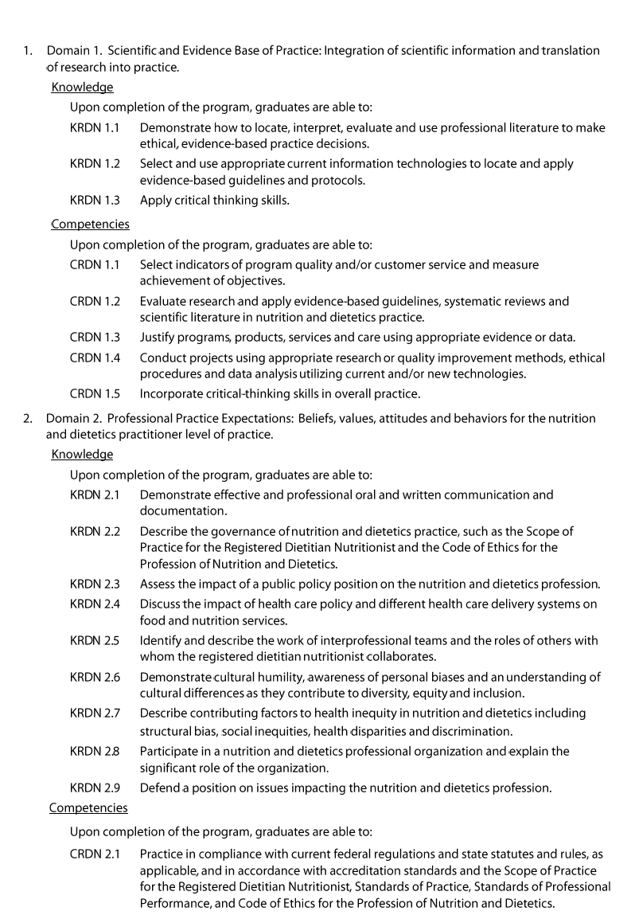

27

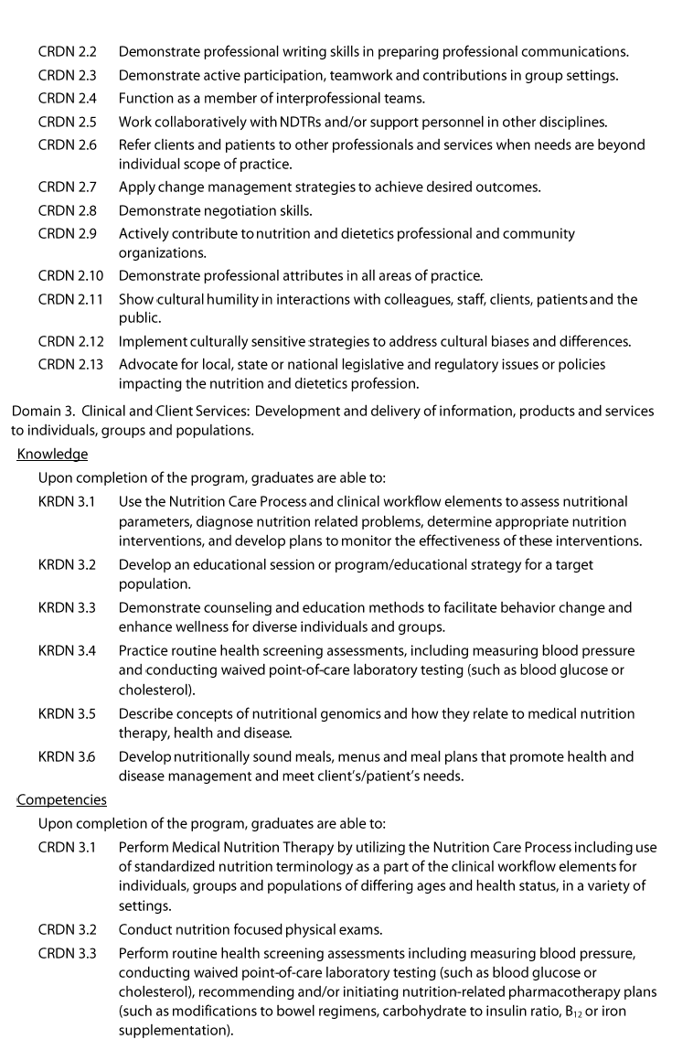

28

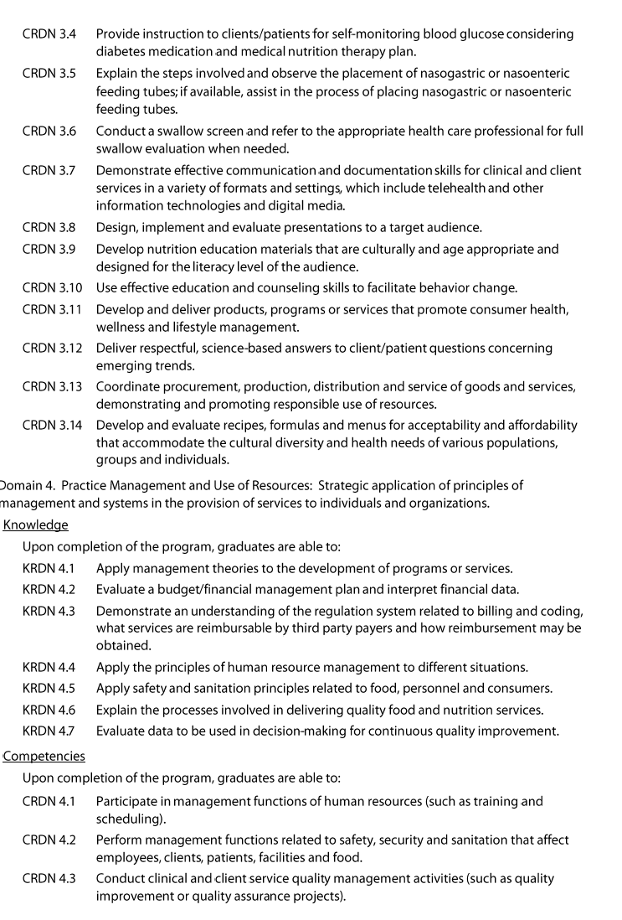

29

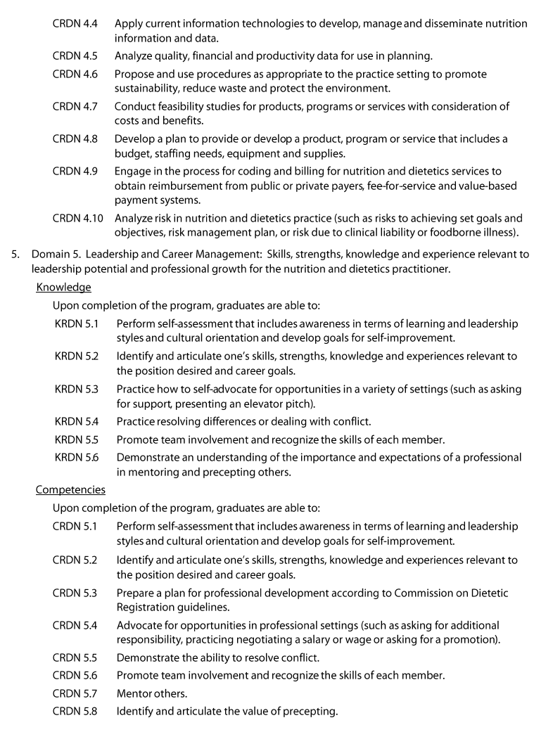

2022 Competencies for Coordinated Program in Dietetics

Handbook Updated 3/4/2022

30

