Do you want to be…  - Considered among the best-trained and best-educated child welfare workers in the nation?  - A competent, satisfied career professional who continues to be enthusiastic, creative, and respected for your work?  - An advocate empowered to coach and mentor children and families based on best practice standards?  The University Partnership Program may be right for you  The University Partnership Program (UPP) seeks to develop creative child welfare caseworkers who are capable of critical thinking and promoting best practices and highest-quality service to children, families, and communities. The program accomplishes this by providing coordinated, integrated, and high quality social work education and training.  Key benefits for social work students and professionals  - Specialized education and waiver of core training.  - Beneficial networking with child welfare professionals across Ohio  - Child Welfare Employment Incentive Payment: $5,000-$10,000 upon obtaining full-time employment and fulfilling program requirements
  University of Akron
  School of Social Work
  411 Polsky Building
  Akron, OH 44325
  330.972.5682
  www.uakron.edu/socialwork
  University of Cincinnati
  School of Social Work
  1515 W. French Hall
  Cincinnati, OH 45221-0108
  513.556.4615
  www.uc.edu/socialwork
  Cleveland State University
  School of Social Work
  Rhodes Tower, room 1417
  Cleveland, OH 44114
  216.687.4560
  www.csuohio.edu/class/socialwork/
  The Ohio State University
  College of Social Work
  1947 College Rd.
  Columbus, OH 43210
  614.292.6288
  www.csw.ohio-sate.edu/
  Ohio University
  Department of Social Work and Public Health
  416 Morton Hall
  Athens, OH 45701
  740.597.1636
  www.ohio.edu/chsp/sph
  University of Toledo
  Social Work Department
  2400 Health and Human Services
  Toledo, OH 43606
  419.530.4197
  www.utoledo.edu/hhs/socialwork
  Wright State University
  Social Work Department
  270 Millett Hall
  Dayton, OH 45435
  937.775.2751
  www.wright.edu/cola/Dept/social_work
  Youngstown State University
  Department of Social Work
  3365 Cushwa Hall
  Youngstown, OH 44555
  330.941.1598
  Email: socialwork@ysu.edu
  Title IV-E University Partnership Program
  Child Welfare Workforce Professional Education Program
  $5,000-$10,000 Employment Incentive Available
  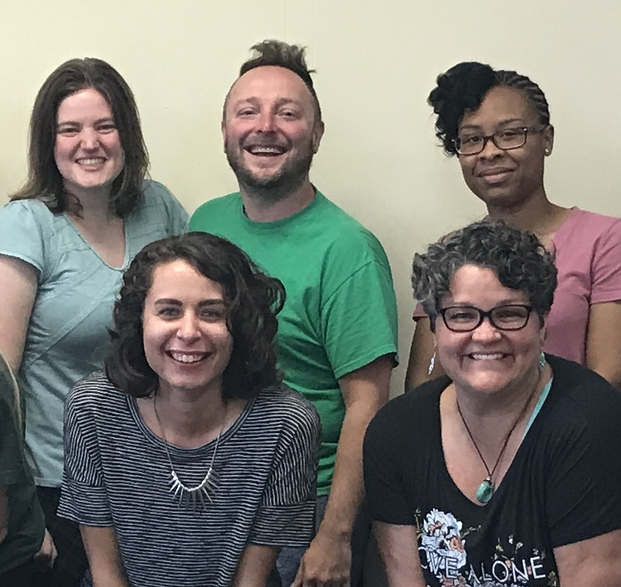
  $5,000-$10,000 Employment Incentive Available
    - Junior and Senior Undergraduate Social Work Students and/or Graduate Social Work students
University Partnership program  Unique and beneficial partnership  The University Partnership Program is a partnership among the Ohio Department of Job and Family Services (ODJFS), Public Children Services Association of Ohio (PCSAO), the Institute for Human Services (IHS), Ohio’s public schools of social work, and Public Children Services Agencies (PCSAs).  Students in Bachelor or Master of Social Work degree programs take special child welfare courses, complete a field placement in a PCSA, and receive an employment monetary incentive after being hired full-time as a PCSA caseworker within 180 days after graduation. Juniors/two year MSW students in UPP must work a minimum of two years and seniors/one year MSW students a minimum of one year in a PCSA after graduation. Students can choose to fulfill the work requirement in any of the 85 county PCSAs throughout Ohio.  Those who complete the program may not have to take the required core training all other new child welfare workers must complete the first year of employment.  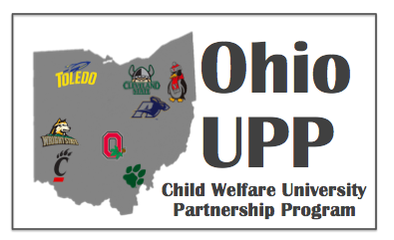 |  |  | Making a positive difference in public child welfare  “Because of UPP, I will be more marketable as I enter the job force; employers know that as a UPP student, I know more of the essential vocabulary and practice skills than the average applicant! Knowing that finding a job will not be as difficult for me as it may be for others is incredible. “  Michael Wadham, Wright State University, UPP student  “I don’t regret my decision to seek a career working with abused and neglected children…not even for one day.”  Tracey Wyatt, Youngstown State University, UPP graduate  “This program is awesome! UPP graduates come into the workforce with knowledge of how things are done and having had the opportunity to job shadow so they know what is expected of them!”  Kim Bayless, PCSA Supervisor  The purpose of the UPP is to positively influence recruitment and retention in public child welfare.  Studies show that social workers who participate in a program such as UPP stay longer and are more satisfied with their employment than those who did not complete such a program. |  |  | Significant financial assistance  UPP provides financial assistance---$5,000-$10,000 in employment incentive—to social work students at selected universities who are interested in pursuing careers in child welfare. The program includes eight universities in Ohio: University Of Akron, University of Cincinnati, Cleveland State University, The Ohio State University, Ohio University, University of Toledo, Wright State University, and Youngstown State University.  Application information  Students interested in applying for UPP must fill out an application and interview with the UPP Campus Coordinator at your school. If selected for the program, you will then sign a UPP contract.  